
CROP-STRESS DETECTION AND GRAIN-PRICE FORECASTING FRAMEWORK USING SATELLITE REMOTE SENSING AND MACHINE LEARNING IN KANO STATE, NIGERIA
BY

IBRAHIM AHMAD GARBA

U22CS1064

THE DEPARTMENT OF COMPUTER SCIENCE

FACULTY OF COMPUTING

AIR FORCE INSTITUTE OF TECHNOLOGY, KADUNA

JUNE, 2026

CROP-STRESS DETECTION AND GRAIN-PRICE FORECASTING FRAMEWORK USING SATELLITE REMOTE SENSING AND MACHINE LEARNING IN KANO STATE, NIGERIA
BY

IBRAHIM AHMAD GARBA

U22CS1064

A project report submitted to the Department of Computer Science Faculty of Computing Air Force Institute of Technology, Kaduna in partial fulfilment of the requirements for the award of the Bachelor of Science (B.Sc.) in Computer Science.
APRIL, 2026

DECLARATION
I IBRAHIM AHMAD GARBA with Matriculation Number U22CS1064, do declare that the work in this research titled CROP-STRESS DETECTION AND GRAIN-PRICE FORECASTING FRAMEWORK USING SATELLITE REMOTE SENSING AND MACHINE LEARNING IN KANO STATE, NIGERIA was carried out by me in the Department of Computer Science, Faculty of Computing, Air Force Institute of Technology, Kaduna. The information derived from the literature has been duly acknowledge in the text and list of references provided. No part of this research has been previously presented for Degree or Diploma in this or any other institution.

IBRAHIM AHMAD GARBA __________________

Signature/Date

CERTIFICATION
The project titled: CROP-STRESS DETECTION AND GRAIN-PRICE FORECASTING FRAMEWORK USING SATELLITE REMOTE SENSING AND MACHINE LEARNING IN KANO STATE, NIGERIA by IBRAHIM AHMAD GARBA with Matric Number U22CS1064 meets the regulations governing the award of the Degree of Bachelor of Science in Computer Science of the Air Forece Institute of Technology, Kaduna and it is accepted for its contribution to scientific knowledge and literary presentation.

Mrs AC Okafor ____________________
Supervisor Signature/Date

Mr SE Iheagwara ____________________
Project Co-ordinator Signature/Date

Sqn Ldr (Dr) OE Olorunshola ____________________
Head of Department Signature/Date

Dr Fatima Adamu Fika ____________________
Dean, FC Signature/Date

Prof Joshua Abah ____________________
External Examiner Signature/Date

DEDICATION
I dedicate this project to God Almighty for the strength, wisdom, and guidance throughout my academic journey. I also dedicate this work to my parents and family, whose unwavering support, encouragement, and sacrifices have made this achievement possible. This project is a reflection of your belief in me and your constant motivation to strive for excellence.

ACKNOWLEDGEMENT
I would like to express my sincere gratitude to my project supervisor for their invaluable guidance, constructive feedback, and continuous support throughout the course of this research. Their expertise and patience greatly contributed to the success of this project.
I also appreciate the lecturers in the Department of Computer Science for the knowledge and skills they have imparted to me during my studies. Their dedication has played a significant role in shaping my academic and professional growth.
My heartfelt thanks go to my friends and colleagues for their encouragement, collaboration, and moral support during the development of this project.
Finally, I extend my appreciation to everyone who, directly or indirectly, contributed to the successful completion of this work.

TABLE OF CONTENTS
DECLARATION I
CERTIFICATION II
DEDICATION III
ACKNOWLEDGEMENT IV
TABLE OF CONTENTS V
LIST OF TABLES VIII
LIST OF FIGURES IX
LIST OF ABBREVIATIONS X
ABSTRACT XI
CHPTER ONE – INTRODUCTION
1.1 Background of the study 1
1.2 Statement of the Problem 2
1.3 Aim and Objectives of the Study 3
1.4 Scope and Limitations of the Study 4
1.5 Significance of the Study 5
1.6 Definition of Terms 6
CHAPTER TWO – LITERATURE REVIEW
2.1 Review of key concepts 7
2.1.1 Vegetation Indices: NDVI and NDMI 7
2.1.2 CHIRPS Rainfall Dataset 8
2.1.3 Rainfall Anomaly Detection 9
2.1.4 Crop Stress Modelling using Remote Sensing 9
2.1.5 Grain Price Forecasting and Time-Series Models 10
2.2 Theoretical/Conceptual Framework 11
2.2.1 Remote Sensing Theory 11
2.2.2 Environmental Stress Modelling Theory 11
2.2.3 Macroeconomic and Machine Learning Forecasting Theory 11
2.2.4 Conceptual Model 12
2.3 Review of Related Literature 13
2.3.1 NDVI and NDMI for Crop Stress Monitoring 13
2.3.2 Rainfall Monitoring using CHIRPS 14
2.3.3 Combined Vegetation-Climate Monitoring 14
2.3.4 Grain Price Forecasting Models 15
2.4 Summary of Literature and Justification for the Study 16
2.4.1 Summary of Literature 16
2.4.2 Research Gaps 16
2.4.3 Justification for the Study 17
CHAPTER THREE - METHODOLOGY (SYSTEM ANALYSIS AND DESIGN)
3.1 Introduction 18
3.2 Description of the Existing System 18
3.3 Analysis of the Proposed System 19
3.3.1 System Architecture 19
3.3.2 Database Design 21
3.3.3 Algorithms and Flowcharts 23
3.4 Method of Data Collection 25
3.4.1 Geospatial Constraint and Land-Cover Isolation 26
3.4.2 Exploratory Data Analysis & Feature Justification 27
3.5 Tools and Techniques 29
3.5 Implementation Architecture and System Structure 30
CHAPTER FOUR – IMPLEMETATION, RESULTS AND DISCUSSION
4.1 Introduction 32
4.2 Data Engineering and Pipeline Implementation 32
4.3 Environmental Baseline Analysis 32
4.4 Feature Importance and the Macroeconomic Shift 34
4.5 Model Evaluation and Comparative Analysis 35
4.5.1 Baseline Statistical Models (ARIMA & SARIMAX) 35
4.5.2 Rigorous Validation (XGBoost Rolling-Origin Cross-Validation) 36
4.5.2 The Winning Model (Advanced Differencing XGBoost) 37
4.5.2 Visualizing Model Performance 37
4.6 Environmental Forecasting: Vegetation Stress (NDVI) 40
4.7 System Deployment: The GeoAI Decision Support Dashboard 42
4.8 Discussion of Findings 43
CHAPTER FIVE – SUMMARY, CONCLUSION AND RECOMMENDATIONS
5.1 Summary of the Study 44
5.2 Conclusion 44
5.3 Limitations of the Study 45
5.4 Recommendation for Future Work 46
REFERENCES
APPENDICES

LIST OF TABLES
Table 4.1 Performance of Baseline Statistical Models 37
Table 4.2 Comparative Performance of XGBoost models Across Crops 38

LIST OF FIGURES
Figure 3.1 End-to-End System Architecture of the Kano GeoAI Framework 21
Figure 3.2 Entity-Relationship (ER) Diagram of the PostgreSQL/PostGIS database 23
Figure 3.3 System Flowchart showing the operational inference process 25
Figure 3.4 Map of the study area (Kano State LGAs ) 26
Figure 3.5 Spatial distribution of the Stable Crop Mask across Kano State 27
Figure 3.6 Annual distribution of wholesale Maize prices (2017–2024) 28
Figure 3.7 Time-series analysis of staple crop prices 29
Figure 3.8 Dual-axis time-series of Maize prices and NGN/USD exchange rate 29
Figure 3.9 Correlation heatmap of environmental variables and exchange rate 30
Figure 3.10 Implementation architecture, system design and data flow 32
Figure 4.1 Dual-axis time-series of Rainfall and Vegetation Health (NDVI) 34
Figure 4.2 Choropleth heatmap of spatial distribution showing average NDVI 35
Figure 4.3 XGBoost Feature Importance 36
Figure 4.4 Time-series comparison of forecasting models across staple crops 40
Figure 4.5 Comparative error analysis of all crop forecasting models 41
Figure 4.6 Time-series comparison of predicted and observed NDVI anomalies 42
Figure 4.7 Feature Importance matrix for the Vegetation Stress model 42
Figure 4.8 User Interface of the Kano GeoAI Decision Support Dashboard 43

LIST OF ABBREVIATIONS
AI – Artificial Intelligence
API – Application Programming Interface
ARIMA – Autoregressive Integrated Moving Average
CHIRPS – Climate Hazards Group InfraRed Precipitation with Station data CSV – Comma-Separated Values
EDA – Exploratory Data Analysis
ER – Entity-Relationship
ETL – Extract, Transform, Load
FEWS NET – Famine Early Warning Systems Network
GADM – Global Administrative Areas
GEE – Google Earth Engine
GeoAI – Geospatial Artificial Intelligence
GIS – Geographic Information System
LGA – Local Government Area
MAE – Mean Absolute Error
MAPE – Mean Absolute Percentage Error
ML – Machine Learning
NDMI – Normalized Difference Moisture Index
NDVI – Normalized Difference Vegetation Index
NGN – Nigerian Naira
OBT – One Big Table
QGIS – Quantum Geographic Information System
RMSE – Root Mean Square Error
SARIMAX – Seasonal Autoregressive Integrated Moving Average with eXogenous factors
SQL – Structured Query Language
USD – United States Dollar
XGBoost – eXtreme Gradient Boosting

ABSTRACT
Agricultural monitoring in Northern Nigeria has traditionally been fragmented and reactive, often separating environmental observations from economic realities. As a result, existing systems struggle to predict extreme food price increases, especially those triggered by macroeconomic shocks. This study presents the Kano GeoAI Food Security Framework, an automated Geospatial Artificial Intelligence system developed to forecast both crop stress and the wholesale prices of staple grains such as maize, sorghum, and millet. An end-to-end Extract, Transform, and Load (ETL) pipeline was designed to integrate satellite-derived environmental indicators (NDVI, NDMI, and CHIRPS rainfall) from Google Earth Engine with macroeconomic data, particularly the NGN/USD exchange rate from the FEWS NET API. The data was stored in a PostgreSQL database with PostGIS support, enabling spatial analysis across the 44 Local Government Areas of Kano State.
To evaluate predictive performance, traditional statistical models (ARIMA and SARIMAX) were compared with a machine learning approach. Analysis of the 2017–2024 dataset revealed a structural market shift in 2023, where currency devaluation became a dominant driver of food price increases. To address this, an XGBoost model with an Advanced Differencing strategy was implemented, focusing on predicting month-to-month price changes. The model achieved an average Mean Absolute Percentage Error (MAPE) of 13.27% and a Mean Absolute Error (MAE) of ₦8,083 for maize during the 2024 peak inflation period, while the vegetation stress model recorded a Root Mean Square Error (RMSE) of 0.5934. The system was further deployed as an interactive Streamlit dashboard for real-time visualization and scenario analysis. Overall, the study demonstrates that integrating environmental and macroeconomic data within a machine learning framework provides a more effective approach for anticipating food security risks.
CHAPTER ONE
INTRODUCTION
  - Background
Agriculture remains one of the most critical sectors in Nigeria, particularly in the northern regions where many people rely on farming for food production and income. Northern Nigeria is responsible for much of the country’s cereal production, especially millet, sorghum, maize, and rice. However, agricultural productivity is becoming more difficult due to changes in climate such as higher temperatures, irregular rainfall, drought, etc. These environmental challenges affect how crops grow and lead to food insecurity in certain regions (Sanusi et al., 2022).
The increasing occurrence of extreme weather events, including prolonged dry spells and erratic rainfall, has put more stress on crops. Traditionally, crop monitoring was done using manual field observations, which are labor-intensive, time-consuming, and only cover small areas. However, recent improvements in satellite technology make it possible to monitor changes over time. Satellite remote sensing is now widely used because it is reliable and a cost-effective tool for monitoring crop stress and unusual changes in vegetation across large geographic areas (Das et al., 2023; Gaznayee et al., 2023).
Vegetation indices like Normalized Difference Vegetation Index (NDVI) and the Normalized Difference Moisture Index (NDMI), calculated from Sentinel-2 imagery provided by the European Space Agency, are commonly used to assess vegetation vigor and moisture conditions. NDVI shows vegetation greenness and biomass, while NDMI is used to measure plant-water content, which helps in detecting moisture stress (Huang et al., 2021; Das et al., 2023). Also, rainfall variability, which an important factor affecting crop health, can be analyzed using the Climate Hazards Group Infrared Precipitation with Stations (CHIRPS) dataset, it provides reliable rainfall data across large areas (Regis et al., 2020).
Environmental monitoring alone is not enough to assess agricultural risk. In recent years, economic instability has significantly contributed to rising food prices. Studying these factors separately makes it harder to understand how regional commodity markets operate. In reality, when vegetation declines and crop yields drop, the situation is worsened by currency inflation, which then affects grain prices in major markets like Dawanau International Market in Kano State (Otitoju et al., 2024). Because crops across Kano State’s 44 Local Government Areas (LGAs) supply regional markets, combining environmental and economic data from across the state can help develop an early-warning system for crop and market risks.
  - Statement of the Problem
Agriculture in Northern Nigeria is highly vulnerable to climatic variability, which affects both crop yields and commodity market stability (Sanusi et al., 2022; Das et al., 2023). Changes in rainfall, temperature extremes, and prolonged dry spells often cause vegetation stress, reduced yields, and supply shocks that impact regional grain markets. Despite the availability of satellite-based vegetation indices and rainfall datasets, several critical gaps remain in addressing these challenges:
  - Lack of Integrated Environmental–Economic Systems: Most studies look at vegetation indices (NDVI, NDMI) and rainfall anomalies separately from grain price forecasting. Very few integrate environmental indicators directly into economic prediction models.
  - Macroeconomic Blind spots: Many forecasting models don’t consider severe currency devaluation. In Nigeria, fluctuations in the Naira-to-USD exchange rate can drive food inflation, causing price spikes even when rainfall and vegetation are favorable (Otitoju et al., 2024).
  - Fragmented Analytical Approaches: Monitoring crop stress and modeling grain prices are often done separately, making it hard to see how environmental stress affects market volatility.
  - Absence of Aggregated Statewide Monitoring: Although satellite data allows local monitoring, Kano State lacks systems that automatically combine LGA-level environmental stress data and use it for time-series grain price forecasts.
  - Reactive Rather Than Predictive Decision-Making: Stakeholders usually react to crop failure or price spikes after they happen, which reduces the effectiveness of mitigation strategies.
  - Data Accessibility and Reliability Constraints: Rainfall and crop-condition records are often incomplete or inconsistent, and historical data is usually stored in separate files instead of scalable databases.
Because of these gaps, farmers, traders, and policymakers lack timely, integrated, and easily accessible information to anticipate production shocks and price changes.
  - Aim and Objectives
Aim
To develop an automated, Geospatial Artificial Intelligence (GeoAI) framework that combines remote sensing data with macroeconomic indicators to forecast environmental stress and simulate future staple food prices in Kano State. This framework will support proactive food security planning.
Objectives
- To build an automated data pipeline (ETL) and PostgreSQL database that continuously collects, processes, and synchronizes satellite climate data (CHIRPS Rainfall, NDVI, NDMI) along with live market prices from the FEWS NET API.
- To analyze how environmental stress signals and Naira exchange rate fluctuations together influence the prices of key staple crops (Maize, Sorghum, and Millet) at the Dawanau International Market, Kano State.
- To develop and optimize non-linear machine learning models (XGBoost) that can forecast short-term crop health and one-step-ahead staple food prices.
- To create an interactive Python Streamlit Early Warning System with a Scenario Simulator that shows live crop stress maps for all 44 LGAs and lets stakeholders to explore how extreme weather or economic events could affect future food prices.
  - Scope and Limitations
Scope of the Study
- Geographical Scope:
The study covers all 44 Local Government Areas (LGAs) of Kano State. Environmental metrics are aggregated at the state level for economic modeling, while LGA-level data are preserved for spatial maps.
- Data Scope:
  - Sentinel-2 imagery to compute NDVI and NDMI.
  - CHIRPS data for analyzing rainfall anomalies.
  - Market prices for key grains (millet, sorghum, maize) from the Dawanau International Market, Kano State, via the FEWS NET API.
  - Macroeconomic data (NGN to USD exchange rates).
  - Official administrative boundary datasets (Shape Files) for Kano State.
- Technical Scope:
  - Development of an automated ETL pipeline using the Google Earth Engine (GEE) Python API.
  - Relational database management with PostgreSQL and SQLAlchemy.
  - Crop stress detection and grain price forecasting using the XGBoost algorithm.
  - Web deployment and creation of an interactive dashboard with Python Streamlit and Plotly libraries.
Limitations
- Spatial Resolution: NDMI and NDVI offer high spatial resolution (10-20m), but CHIRPS rainfall data is coarser (around 5km), which limits detailed village-scale hydrological analysis.
- Cloud Cover: Sentinel-2 optical imagery can be affected by cloud cover, especially in the peak of rainy season. Cloud-masking algorithms and median composite aggregation are used to maintain data quality.
- Market Data Reliability: Market price data may have missing periods. We address this using statistical linear interpolation and through data cleaning in the ETL pipeline.
- Computational Constraints: Processing seven years of satellite imagery for 44 LGAs is computationally intensive. Google Earth Engine's cloud infrastructure is used to compute zonal statistics before downloading the aggregated data locally.
  - Significance of the Study
This research is important for several reasons:
- Improved Early Detection of Crop Stress: By combining NDVI, NDMI, and rainfall anomalies in a single database, the system gives timely, automated insights into crop health.
- Enhanced Grain Price Forecasting: Linking environmental indicators with macroeconomic factors, like exchange rates, improves forecast accuracy and helps explains complex market behaviors.
- Policy Support and Food Security Planning: The interactive Scenario Simulator lets agricultural agencies and policymakers to test different scenarios, providing evidence-based support for food security planning.
- Support for Farmers and Traders: Early-warning insights help traders anticipate market changes and enable extension workers to give better advice to farmers.
- GeoAI Innovation: The study provides a replicable, enterprise-level data engineering framework that combines remote sensing, databases, and machine learning for future research.
- Academic Contribution: It addresses a research gap by creating a localized, statewide environmental and economic forecasting system for Northern Nigeria.
  - Definition of Terms
- GeoAI (Geospatial Artificial Intelligence): The combination of artificial intelligence and geospatial data, such as satellite imagery, to analyze and predict spatial patterns.
- NDVI (Normalized Difference Vegetation Index): A remote sensing measure used to assess vegetation greenness and overall plant health based on how plants reflect certain light wavelengths.
- NDMI (Normalized Difference Moisture Index): A satellite-derived index that measures moisture or water content in plant canopies.
- CHIRPS (Climate Hazards Group InfraRed Precipitation with Station data): A widely dataset that estimates daily and monthly rainfall.
- ETL Pipeline (Extract, Transform, Load): An automated software process that collects raw data from different sources (like APIs), cleans and structures it, and stores it in a centralized database.
- XGBoost (eXtreme Gradient Boosting): A fast and powerful machine learning algorithm used in this study to model complex, non-linear relationships for forecasting.
- Macroeconomic Indicator: Broad economic measures, such as currency exchange rates, used to understand the overall health of an economy and inflation pressures.

CHAPTER TWO
LITERATURE REVIEW
  - Review of Key Concepts
Agricultural systems in developing regions are increasingly vulnerable to climate variability and environmental stressors. This creates a growing need for advanced methods to monitor vegetation health, detect anomalies, and forecast economic outcomes (Das et al., 2023; Gaznayee et al., 2023). Integrating remote sensing technologies, high-resolution climate datasets, macroeconomic indicators, and machine learning models has established a new paradigm for agricultural intelligence (Huang et al., 2021; Varouchakis et al., 2025).
This section reviews the key concepts underlying this study, including:
- Vegetation indices (NDVI and NDMI) for monitoring crop health and moisture stress (Huang et al., 2021; Das et al., 2023).
- Rainfall datasets and anomaly detection, particularly using CHIRPS, to understand environmental pressures on agriculture (Regis et al., 2020).
- Crop stress modeling frameworks for early detection of production risks (Gaznayee et al., 2023; Varouchakis et al., 2025).
- Macroeconomic volatility and its influence on commodity inflation (Otitoju et al., 2024).
- Time-series forecasting techniques for modeling grain price behavior (Sanusi et al., 2022).
These concepts form the methodological foundation for linking environmental indicators with economic realities in a unified, statewide agricultural monitoring framework.
    - Vegetation Indices: NDVI and NDMI
Vegetation indices are spectral transformations of satellite imagery that highlight vegetation characteristics based on reflectance values from specific wavelength bands.
The Normalized Difference Vegetation Index (NDVI) is widely used due to its simplicity and effectiveness in measuring vegetation vigor (Huang et al., 2021; Das et al., 2023). NDVI is based on strong absorption of red light by chlorophyll and the high reflectance of near-infrared (NIR) light by plant cells. It is calculated as:
$$NDVI= \frac{(NIR-RED)}{(NIR+RED)}$$
NDVI values range from -1 to +1, where higher values generally indicate healthier and denser vegetation. It is commonly used to estimate above-ground biomass, canopy structure, and photosynthetic activity. However, NDVI tends to saturate in very dense vegetation, meaning that further increases in biomass do not to significant changes in NDVI values. This reduces its sensitivity during peak growth periods (Varouchakis et al., 2025).
To address the moisture-related limitations of NDVI, the Normalized Difference Moisture Index (NDMI) was developed. NDMI uses the Near-Infrared (NIR) and Short-Wave Infrared (SWIR) bands, which are sensitive to plant water content. It is calculated as:
$$NDMI= \frac{(NIR-SWIR)}{(NIR+SWIR)}$$
NDMI is widely used to monitor vegetation moisture conditions, detect drought stress, and track changes in canopy water content (Das et al., 2023; Varouchakis et al., 2025). It is particularly useful during the mid-season period, when water stress begins to appear but may not yet be visible through changes in vegetation greenness captured by NDVI.
While NDVI measures greenness, NDMI reflects moisture conditions, using both indices together improves the detection of early-stage crop stress.
    - CHIRPS Rainfall Dataset
The Climate Hazards Group Infrared Precipitation with Stations (CHIRPS) dataset combines in-situ rainfall measurements with satellite-derived precipitation estimates (Regis et al., 2020). It provides daily, pentadal, and monthly rainfall data at spatial resolution of 5 km, covering the period from 1981 to the present. Its long-term consistency and integration of station data make it reliable for climate monitoring, agricultural assessments, and drought detection.
CHIRPS is particularly suited for regions with limited ground weather station coverage, such as Northern Nigeria. It can capture extreme rainfall events, seasonal onset patterns, and cumulative rainfall deficits, which are important for analyzing rainfall anomalies and assessing crop stress (Regis et al., 2020).
    - Rainfall Anomaly Detection
Rainfall anomalies indicate deviations from long-term rainfall averages and are used to identify unusually wet or dry periods. These anomalies can be measured using:
- Standardized Anomaly Index (SAI)
- Z-score standardization
- Percent of normal precipitation (PNP)
- Standardized Precipitation Index (SPI)
In this study, Z-score standardization converts raw rainfall totals into comparable anomaly values. These anomalies are important because crop performance depends heavily on both the timing and distribution of rainfall. Persistent negative anomalies often indicate moisture stress, which increases the risk of reduced crop yield (Regis et al., 2020).
    - Crop Stress Modelling using Remote Sensing
Crop stress refers to environmental or physiological conditions that negatively affect plant health and productivity. Remote sensing allows large-scale monitoring by detecting changes in canopy reflectance, temperature, moisture, and biomass.
Integrated crop stress models commonly combine:
- NDVI for greenness and biomass (Huang et al., 2021; Das et al., 2023).
- NDMI for evaluating moisture stress (Varouchakis et al., 2025).
- Rainfall anomalies for representing hydrological stress (Regis et al., 2020).
- Land surface temperature for detecting thermal stress.
- Phenology-based indices for identifying growth anomalies.
Early detection is important because stress often develops before visible symptoms appear. Remote sensing therefore provides useful early-warning insights for farmers and agricultural agencies (Das et al., 2023; Varouchakis et al., 2025).
    - Grain Price Forecasting and Time-Series Models
Price forecasting involves predicting future commodity prices using historical data and relevant explanatory variables. Common approaches include:
- ARIMA (Autoregressive Integrated Moving Average)
- SARIMA (Seasonal ARIMA)
- SARIMAX (Seasonal ARIMA with exogenous variables)
- Machine learning models: XGBoost, Random Forest, and LSTM neural networks (Sanusi et al., 2022).
Grain prices in Northern Nigeria are influenced by several factors, including:
- Crop yield variability
- Market supply chains
- Environmental stress
- Transportation costs
- Demand fluctuations
- Policy interventions
- Macroeconomic Volatility (e.g., currency exchange rates), which can drive food inflation independently of weather conditions (Otitoju et al., 2024).
Traditional statistical models effective at capturing temporal patterns. However, machine learning models such as XGBoost are better suited for handling complex, nonlinear relationships between multiple predictors including NDVI, NDMI, rainfall anomalies, and exchange rates.
By combining these diverse data sources into a centralized forecasting framework, it becomes possible to improve prediction accuracy and provides deeper insights into the factors driving price volatility (Sanusi et al., 2022).
  - Theoretical / Conceptual Framework
This study is based on four main theoretical foundations: remote sensing theory, environmental stress modelling, macroeconomic price theory, and machine learning forecasting theory. Together, these frameworks provide a solid basis for local environmental indicators and economic factors into a unified predictive system.
    - Remote Sensing Theory
Remote sensing theory is based on the idea that objects on the Earth’s surface reflect, absorb, and emit electromagnetic radiation differently depending on their physical properties. Vegetation, water bodies, and bare soil each have distinct spectral signatures. The interaction between electromagnetic radiation and plant canopies makes it possible to monitor vegetation using reflectance bands.
Healthy vegetation absorbs red light for photosynthesis and reflects strongly in the near-infrared (NIR) spectrum due to its leaf cellular structure. In contrast, moisture stress alters leaf structure, reducing NIR reflectance and increasing short-wave infrared (SWIR) reflectance. These relationships explain why NDVI and NDMI are useful satellite-derived indicators of vegetation health, water content, and crop stress.
    - Environmental Stress Modelling Theory
Environmental stress modelling shows that crop stress arises from complex interactions among climatic, hydrological, biological, and soil-related factors. Stress responses such as reduced greenness, moisture loss, and stunted growth can be observed through remote sensing because they affect how vegetation reflects light.
Rainfall anomalies are a major cause of vegetative stress in semi-arid regions like Kano State. Rainfall deficits reduce soil moisture, leading to early senescence and a decline in agricultural productivity. This is why CHIRPS rainfall data is combined with vegetation indices to achieve early stress detection before visible crop failure occurs.
    - Macroeconomic and Machine Learning Forecasting Theory
Traditional time-series forecasting theory emphasizes that future values of a variable can be predicted from historical patterns, seasonal trends, and external factors using linear models like ARIMA or SARIMAX. However, these statistical models often struggle to capture the complex non-linear relationships present in modern agricultural markets, especially during periods of macroeconomic instability.
In developing economies, macroeconomic theory shows that currency devaluation (e.g., the Naira to USD exchange rate) increases the cost of agricultural inputs, transportation, and ultimately, market grain prices (Otitoju et al., 2024).
To handle these complex interactions, this study adopts a machine learning-based forecasting approach. Gradient-boosted tree algorithms such as XGBoost are used to model the non-linear relationships between environmental stress across multiple LGAs, currency fluctuations, and resulting economic outcomes.
    - Conceptual Model
Based on the reviewed theories, the conceptual model of this system integrates four key components:
- Environmental Indicators
  - NDVI and NDMI vegetation indices aggregated across all 44 Local Government Areas (LGAs) of Kano State.
  - CHIRPS rainfall anomalies processed using Google Earth Engine.
- Macroeconomic Indicators
  - National currency exchange rate volatility (NGN/USD).
- Crop Stress Detection
  - Spatiotemporal analysis of vegetation anomaly.
  - Early-warning of moisture deficit.
- Grain Price Behavior & Forecasting
  - Non-linear machine learning forecasting models (XGBoost).
  - Linking environmental stress conditions with economic factors to explain price volatility.
The model assumes that localized environmental stress influences crop yield, while macroeconomic instability affects purchasing power. By integrating these data sources within a centralized relational database and applying machine learning techniques, the system improves forecasting accuracy and provides actionable early-warning insights food security.
  - Review of Related Literature
This section provides a comprehensive review of empirical and conceptual studies that examine the integration of vegetation indices, rainfall anomalies, and grain price forecasting models. The review highlights previous research findings, methodological approaches, and existing gaps that justify the development of a unified GeoAI framework for crop stress detection and food price prediction.

    - NDVI and NDMI for Crop Stress Monitoring
Huang et al. (2021) highlighted the effectiveness of Normalized Difference Vegetation Index (NDVI) for assessing overall vegetation vigor, but noted that it saturates in dense canopies, reducing its sensitivity to small changes in biomass. This limitation makes NDVI less reliable during peak growth stages, particularly in regions with dense vegetation.

Das et al. (2023) evaluated drought conditions in Bangladesh using multiple vegetation indices and found that Normalized Difference Moisture Index (NDMI) outperforms NDVI in detecting moisture stress, especially under water-deficit conditions. NDMI shown to capture early signs of water stress, allowing for earlier detection compared to NDVI.

Similarly, Varouchakis et al. (2025) applied NDVI and NDMI to analyze vegetation dynamics and reported that NDMI responds strongly to variations in plant moisture content, making it particularly valuable for monitoring drought conditions and identifying early-stage stress before visible damage occurs.

Collectively, these studies indicate that NDVI and NDMI are complementary: NDVI vegetation greenness and biomass, while NDMI provides insights into moisture-related stress. However, many existing studies use these indices independently, without integrating them into predictive modeling frameworks, which limits their utility in translating environmental signals into actionable insights for agricultural insights.
In response, this study integrates NDVI and NDMI as core input features within a machine learning framework, enabling simultaneous monitoring of vegetation vigor and moisture stress and linking these signals to crop yield conditions and staple grain price behavior.

    - Rainfall Monitoring using CHIRPS
Regis et al. (2020) analyzed historical rainfall patterns in West Africa using the CHIRPS dataset and demonstrated that it provides reliable estimates for detecting extreme rainfall events and long-term precipitation trends. Their study highlights CHIRPS’ ability to capture both seasonal variability and cumulative rainfall deficits, making it particularly useful for agricultural assessments.

CHIRPS is especially valuable in regions sparse ground-based weather stations, such as Northern Nigeria, where consistent and accurate rainfall measurements are often lacking. By integrating satellite-derived precipitation estimates with station data, CHIRPS improves the reliability of climate monitoring and supports drought detection.

Despite its widespread use for rainfall analysis and drought monitoring, many studies employ CHIRPS primarily for descriptive purposes rather than integrating it into predictive framework. Consequently, its potential for contributing to early-warning systems and predictive agricultural modeling remains underexploited.

To address this gap, the present study incorporates CHIRPS rainfall data into an automated pipeline and applies anomaly detection techniques to generate standardized rainfall indicators. These indicators are then combined with vegetation indices and macroeconomic variables to enhance the prediction of crop stress and staple grain price fluctuations.

    - Combined Vegetation–Climate Monitoring
Gaznayee et al. (2023) combined NDVI, NDMI, and climatic variables to evaluate irrigation system performance, demonstrating that combining vegetation indices with climate data produces more accurate assessments of vegetation health than using either data source independently. Their findings demonstrate the importance of multi-source data fusion for environmental monitoring.
Linking vegetation signals with climatic conditions provides more complete understanding of crop responses to environmental stress. This integration is particularly critical in semi-arid regions, where moisture availability and vegetation dynamics must be jointly analyzed to accurately assess agricultural conditions.

Despite these advantages, many studies stop at monitoring and descriptive analysis without extending integrated datasets into predictive economic models. As a result, the direct connection between environmental stress and market outcomes, such as grain price fluctuations, remains underexplored.

To address this gap, the present study extends the integrated vegetation-climate approach by combining NDVI, NDMI, and rainfall anomalies within a machine learning framework. This allows environmental signals to inform grain price forecasting directly, creating a more comprehensive and actionable agricultural intelligence system.

    - Grain Price Forecasting Models
Sanusi et al. (2022) investigated grain price forecasting in Nigeria using ARIMA and neural network models. Their findings showed that while ARIMA effectively captures temporal patterns, machine learning approaches generally achieve higher accuracy when additional explanatory variables, such as climate factors, are incorporated. This emphasizes the importance of including external drivers beyond historical price data.

However, existing studies do not include strong explanatory variables that directly link localized environmental stress to grain price fluctuations. Forecasting models often rely primarily on historical price trends neglecting real-time environmental indicators such as vegetation indices (NDVI, NDMI) or rainfall anomalies.

Moreover, the majority of the literature pays limited attention to macroeconomic instability, particularly currency exchange rate fluctuations. In Nigeria, context, Naira-to-USD exchange rate volatility can significantly affect food prices by increasing the cost of inputs, transportation, and market transactions, even under favorable environmental conditions (Otitoju et al., 2024).
These gaps highlight the need for a more integrated forecasting approach. Accordingly, this study combines environmental indicators (NDVI, NDMI, and rainfall anomalies) with macroeconomic variables (exchange rate fluctuations) within a machine learning framework. Using XGBoost enables the model to capture complex, non-linear relationships between these factors, providing a more accurate and actionable representation of grain price behavior.

  - Summary of Literature and Justification for the Study
    - Summary of Literature
The reviewed literature demonstrates substantial progress in vegetation monitoring, rainfall analysis, and grain price forecasting. Vegetation indices such as NDVI and NDMI are widely applied for assessing crop health, with NDVI capturing overall greenness and biomass, and NDMI offering better sensitivity to moisture stress. The CHIRPS dataset has proven valuable for rainfall monitoring and drought assessment, especially in regions with limited ground-based weather stations, such as Northern Nigeria.

Studies that integrate vegetation indices with climate variables consistently show that multi-source approaches yield more accurate assessments of environmental conditions than single-source analyses. In grain price forecasting, both statistical models (e.g.,ARIMA) and machine learning techniques have been used, with machine learning methods demonstrating superior performance when explanatory variables and environmental factors are incorporated. Despite these advancements, critical gaps remain in the literature.

    - Research Gaps
- Limited Localized, Statewide Monitoring Systems: Most studies focus on regional or national scales, with few frameworks aggregating environmental indicators across all Local Government Areas (LGAs) in Kano State for high-resolution spatial analysis.
- Weak Integration of Environmental and Economic Variables: Vegetation indices and rainfall data are rarely combined with macroeconomic indicators, indicators such as currency exchange rates in predictive models, limiting understanding of grain price dynamics.
- Lack of Automated and Scalable Data Pipelines: Many studies rely on static datasets and manual processing, which hinders real-rime monitoring and reduces scalability and reproducibility.
- Underutilization of Multi-Source Data Fusion for Forecasting: While some research integrates vegetation and climate data, few extend this into machine learning-based models that link environmental stress to economic outcomes.
- Limited Decision-Support Systems for Policymakers: Most studies focus on analysis rather than application, providing minimal interactive tools for real-time policy planning or stakeholder decision-making.
    - Justification for the Study
These gaps highlight the need for an integrated, application-oriented approach to agricultural monitoring and forecasting. This study addresses these limitations by developing a GeoAI framework that fuses satellite-derived environmental data with macroeconomic indicators in a single, automated system.
The study introduces an end-to-end data pipeline that continuously ingests, processes, and stores multi-source data in a PostgreSQL database, improving data accessibility and scalability. By applying the XGBoost machine learning algorithm, the system captures complex, non-linear relationships between vegetation stress, rainfall variability, and exchange rate fluctuations, improving forecast accuracy.
Furthermore, deploying a Python Streamlit-based interactive dashboard transforms analytical outputs into a practical decision-support tool. The spatial heatmap and Scenario Simulator in the dashboard, enables stakeholders to visualize crop stress patterns and explore potential impacts of environmental and economic changes on future grain prices.
Overall, this study goes beyond traditional static analyses by providing a scalable, integrated, and actionable framework that supports early warning systems and informed decision-making for food security in Northern Nigeria.
CHAPTER THREE
METHODOLOGY
SYSTEM ANALYSIS AND DESIGN
  - Introduction
This chapter explains the methodology, system analysis, and architectural design of the Kano GeoAI Food Security Framework. Most traditional studies focus on static analysis, this study adopts a Software Engineering approach to develop an automated, end-to-end Geospatial Artificial Intelligence system. The chapter describes the evaluation of existing manual systems, the design of the proposed automated framework, the database schema, the machine learning models employed, and the data engineering pipelines used to integrate environmental and macroeconomic indicators.
  - Description of the Existing System
Currently, agricultural monitoring and grain price forecasting in Northern Nigeria rely on fragmented and largely reactive systems. These approaches have several challenges:
- Manual Data Collection: Crop health is mainly assessed using ground-based agricultural extension surveys. These methods are time-consuming, costly, and cover only small areas, making large-scale state-wide monitoring difficult.
- Separate Economic and Environmental Data: Market analysts typically examine price trends independently, while meteorological data is analyzed separately. There is no system that clearly connects environmental conditions, such as drought in a specific LGA, to changes in grain prices at major markets like Dawanau.
- Ignoring macroeconomic factors: Existing systems often fail to incorporate macroeconomic factors such as currency devaluation (Naira-to-USD exchange rate). This omission leads to inaccurate forecasts particularly during periods of high inflation.
- Static Reports: Outputs are usually presented as static reports (e.g., PDFs or spreadsheets), which do not provide interactive tools for scenario analysis of policy evaluation. As a result, decision-making remains reactive rather than proactive.
  - Analysis of the Proposed System
The proposed GeoAI system solves the problems in the existing system by replacing manual processes with automated data acquisition, centralized database storage, and predictive modeling into a unified system.
    - System Architecture
The system is designed as a modular and automated strucure. To solve the problem found disconnected systems, the framework is designed as a continuous, end-to-end data pipeline (Figure 3.1). The architecture is divided into four primary interacting components:
- Data Extraction Pipeline: Python scripts (fetch_satellite_api.py and fetch_prices_api.py) connect directly to the Google Earth Engine (GEE) API and the FEWS NET API. The GEE pipeline extracts Sentinel-2 imagery and CHIRPS rainfall data, applying a Dynamic World crop-mask to isolate active farmlands across all 44 LGAs. The FEWS NET pipeline extracts historical and current grain prices along with the national exchange rate data.
- ETL and Data Warehouse: The etl_pipeline.py script functions as the main processing stage. It pulls raw data from the PostgreSQL staging tables, aggregates daily satellite data into monthly averages, computes statistical Z-score anomalies, and creates lag (Time Travel) features. The final output is loaded into the Denormalized Feature Store (One Big Table).
- Machine Learning Engine: The processed data from the Feature Store is used to train the models. The system applies non-linear XGBoost algorithms to produce simultaneous one-month-ahead forecasts for both environmental vegetation stress and macroeconomic grain prices.
- Interactive Frontend: A Streamlit-based web application is the user interface. It retrieves historical context directly from the database and integrates the ML predictions, displaying them to policymakers through interactive spatial heatmaps and an economic scenario simulator.
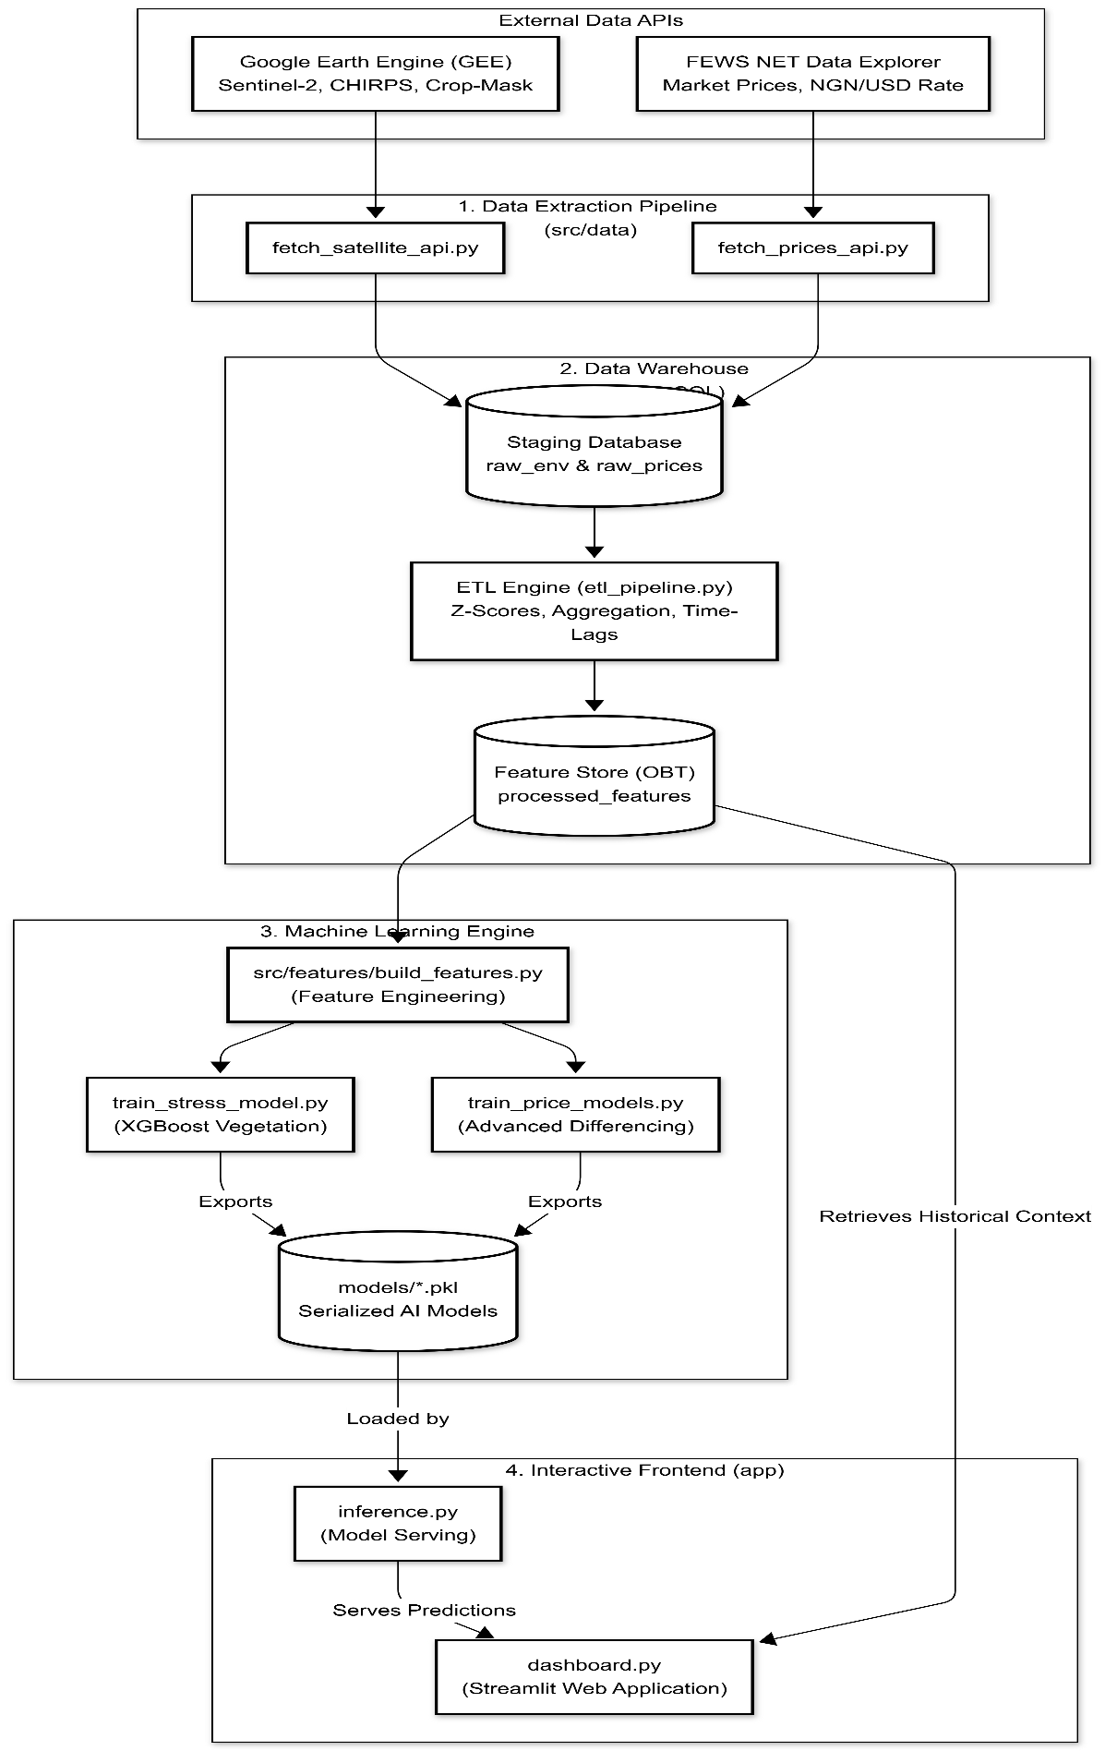
Figure 3.1: End-to-End System Architecture of the Kano GeoAI Framework. The block diagram shows flow of data from external APIs into the ETL pipeline, then into the PostgreSQL data warehouse, followed by the XGBoost machine learning engine, and finally deployed through the Streamlit user interface.
    - Database Design
To ensure data integrity and scalability, the system transitions from flat CSV files to a PostgreSQL relational database managed via SQLAlchemy.

Architectural Design: Staging and "One Big Table" (OBT) Schema
Instead of using fully normalized database structure (such as 3rd Normal Form) which is mainly used for transactional systems, this study adopts a machine learning-focused data Warehouse design. The system uses a staging layer to store raw data and a denormalized "One Big Table" (OBT) that combines all features for efficient model training.
The Entity-Relationship desing (Figure 3.2) is structured on three main tables:
- raw_env_data: This table stores raw environmental data at the LGA level collected from Google Earth Engine.
- raw_fewsnet_prices: This table contains historical grain prices and macroeconomic exchange rate data obtained from the FEWS NET API.
- processed_features: This serves as the main feature table created by the ETL process. It contains merged, interpolated, and state-wide aggregated data, including all temporal lag features, Z-score anomalies, and one-hot encoded seasonal variables used for the XGBoost models.
Spatial Database Integration (PostGIS)
In addition to the standard relational data, the system uses the PostGIS extension to manage spatial data. A separate table (kano_lga_boundaries) stores the boundary coordinate data for all 44 Local Government Areas in polygon format. Instead of keeping this data in local shapefiles (.shp), it is stored directly in the database. This allows both spatial data and economic data to be managed together in one system.
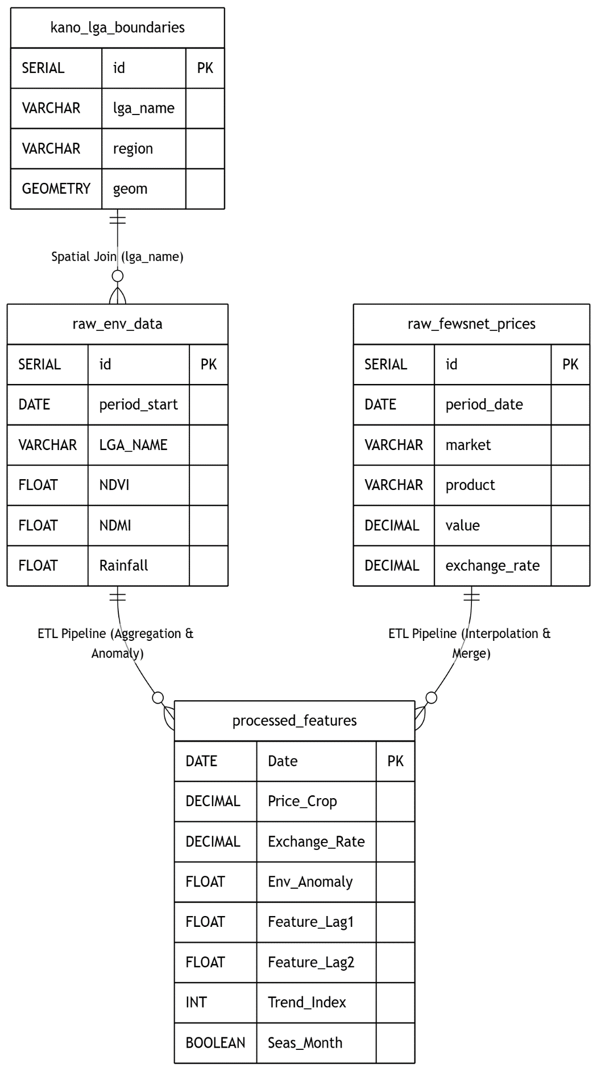

Figure 3.2: Entity-Relationship (ER) Diagram of the PostgreSQL/PostGIS database. The schema shows the integration of the spatial geometry table (kano_lga_boundaries), and the flow of data from the staging tables into the main denormalized machine learning feature table used for modeling.
    - Algorithms and Flowcharts
The core predictive model of this system is XGBoost (eXtreme Gradient Boosting). Compared to traditional linear models like ARIMA and SARIMAX, XGBoost is an ensemble learning algorithm that builds multiple decision trees step by step. Where each new tree attempts to correct the residual errors of the previous ones.
XGBoost was selected for this study due to its ability to model complex, non-linear relationships which are common in agricultural and economic systems. It can capture how environmental and economic factors interact. For example, the model can learn conditional logic, such as: “If Rainfall is normal (positive anomaly) BUT the Exchange Rate spikes above ₦1,500/USD, then the price of Maize will still increase.”
The algorithm adopts a "Difference Strategy" for price prediction. Instead of predicting the actual grain prices, the model is trained to predict the month-to-month change (difference) in price. This approach helps reduce the impact of non-stationary trends and allows the model to focus on the impact of environmental and economic factors.
Operational Inference Flow
To apply this algorithmic theory in a live environment, the system uses a dynamic inference pipeline (Figure 3.3). Instead of making static predictions, the system is designed to respond to user-define economic and environmental scenarios through the Streamlit web application.
The inference cycle begins by querying the PostgreSQL database to load the most recent historical context. If the user modifies any Scenario Simulator (for example, adjusting the exchange rate), these overrides are applied to the baseline data. The system then calculates the necessary temporal lag variables and splits the execution into two separate processes: one for the XGBoost vegetation stress model, and the other for the XGBoost Price models.
Because the price algorithm relies on the Difference Strategy, a final mathematical reconstruction step is required. The system adds the model's predicted price variance to the last known baseline price to calculate the absolute forecasted value. Finally, these aggregated forecasts are displayed on the dashboard as spatial heatmaps and trend charts.
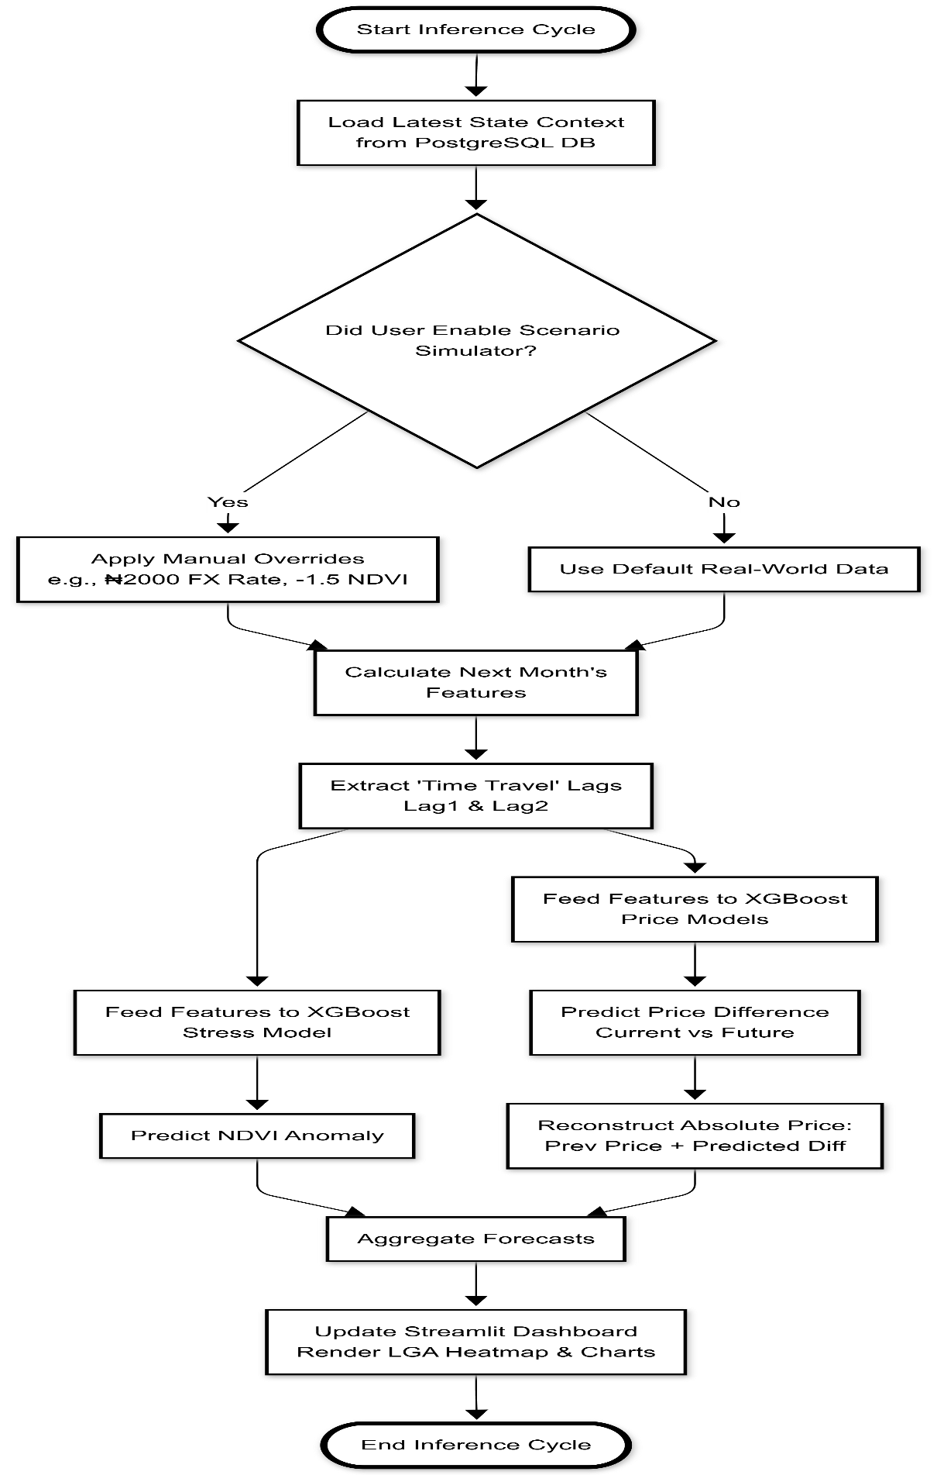
Figure 3.3: System Flowchart showing the operational inference process from database retrieval, through the scenario simulator and model prediction to the final output visualization
  - Method of Data Collection
The system replaces manual data collection with automated, programmatic data extraction from reliable global sources. These sources are grouped into two main categories:
- Remote Sensing Data: Remote sensing data is obtained using the Google Earth Engine (GEE) Python API. Sentinel-2 Surface Reflectance imagery (10m spatial resolution) is used to compute NDVI and NDMI, while the CHIRPS dataset provides corresponding rainfall (precipitation) data. In addition, the Global Administrative Areas (GADM) dataset is used to define the geospatial boundaries of the 44 Local Government Areas (LGAs) in Kano State. The Kano LGA Shapefile is alo uploaded as a custom asset to the Google Earth Engine to enable accurate spatial clipping and aggregation of satellite data.
- Economic and Market Data: Economic and market data is sourced from the Famine Early Warning Systems Network (FEWS NET) Data Explorer API. This provides standardized, historical, and current monthly prices for key staple crops (maize, sorghum, and millet) from the Dawanau International Market, as well as NGN/USD exchange rate data.
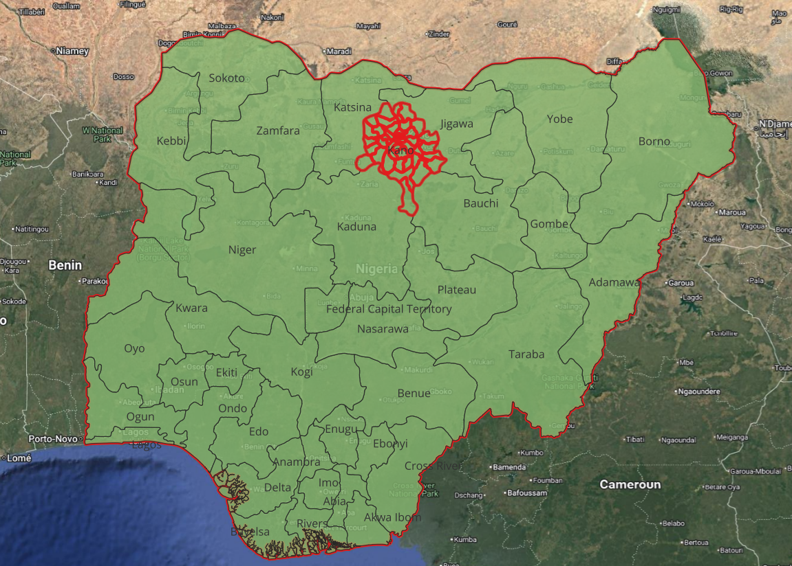
Figure 3.4: Map of the study area, showing the geographic location of Kano State within Nigeria (inset) and the administrative boundaries of its 44 Local Government Areas (LGAs).
    - Geospatial Constraint and Land-Cover Isolation
The preliminary stage of the spatial analysis involved defining accurate geographic boundries for the study. Using the GADM (Version 4.1) dataset, the polygon geometries of Kano State’s 44 Local Government Areas (LGAs) were mapped and validated. However, using full LGA boundaries alone for satellite extraction introduces a major issue known as urban noise. In this case, non-agricultural areas such as urban settlements (e.g., Kano Metropolis) may be incorrectly interpreted as vegetation loss or drought conditions.
To address this problem, the vector boundaries were combined with the Dynamic World (V1) Land Cover Dataset. Only pixels classified as “Crops” (Class 4) across the 2017–2024 period were extracted. This process generated a Stable Crop Mask, which isolates only consistently active agricultural areas.
This filtering step ensures that the model is trained only on real farmland reflectance values, removing interference from urban and barren land. As a result, the quality of the environmental data is improved, and the performance of the XGBoost model becomes more reliable.
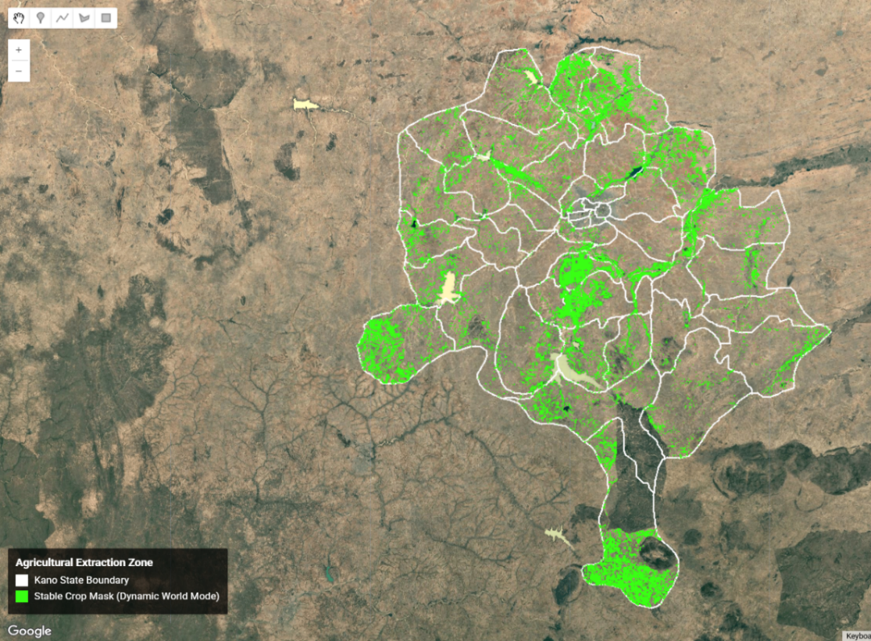
Figure 3.5: Spatial distribution of the Stable Crop Mask across Kano State. Highlighted areas represent pixels consistently classified as cropland by the Dynamic World (V1) dataset from 2017 to 2024, used to isolate agricultural regions from urban and non-vegetated land.
    - Exploratory Data Analysis & Feature Justification
Before finalizing the predictive model, Exploratory Data Analysis (EDA) was conducted to justify the inclusion of macroeconomic variables alongside environmental indicators.
The Initial analysis of the Dawanau International Market data revealed significant price volatility. As shown in the annual distribution of wholesale maize prices (Figure 3.6), prices remained relatively stable vetween 2017 and 2022, with consistent interquartile ranges. However, a sharp increase in variability and extreme outliers was observed in 2023 and 2024, indicating a major disruption in market stability.
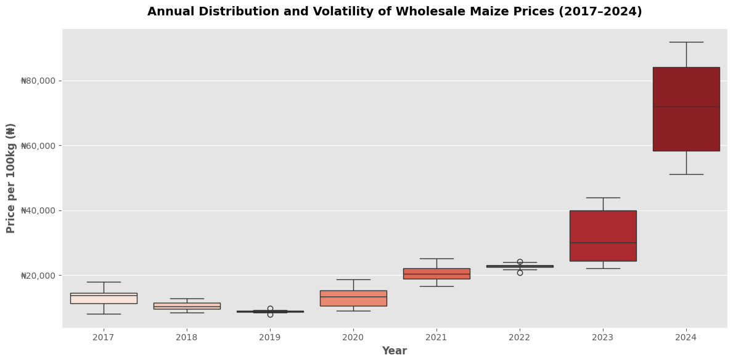

Figure 3.6: Annual distribution of wholesale Maize prices (2017–2024). The widening of the distribution in 2023 and 2024 reflects a significant increase in market volatility.

To investigate the cause of this disruption, a time-series analysis was conducted across maize, sorghum, and millet prices (Figure 3.7). The results show a clear structural break around May 2023, where prices began to rise rapidly across all commodities. This shift aligns with major national economic policy changes, particularly the removal of fuel subsidies, which significantly affected transportation and distribution costs.
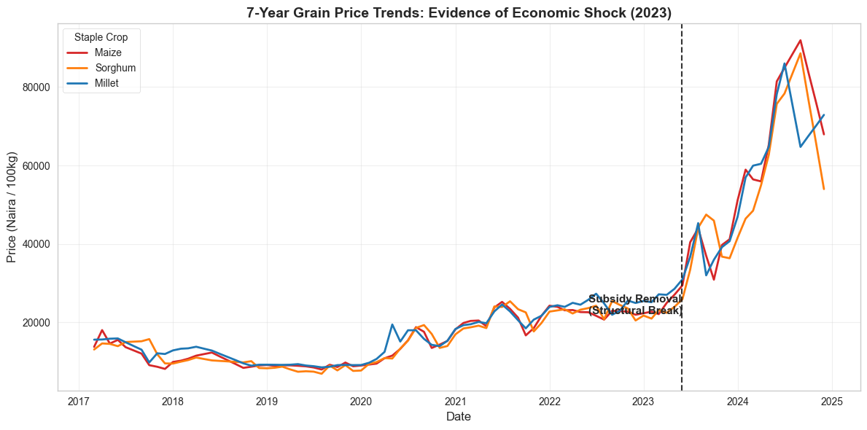
Figure 3.7: Time-series analysis of staple crop prices, showing a structural break and sharp price increase beginning around may 2023.
Further analysis revealed a growing disconnect between environmental conditions and market prices. Even during periods of favorable rainfall and healthy NDVI values, grain prices continued to increase. A comparison between maize prices and the NGN/USD exchange rate (Figure 3.8) showed a strong parallel movement, suggesting that currency devaluation played a major role in driving food inflation.
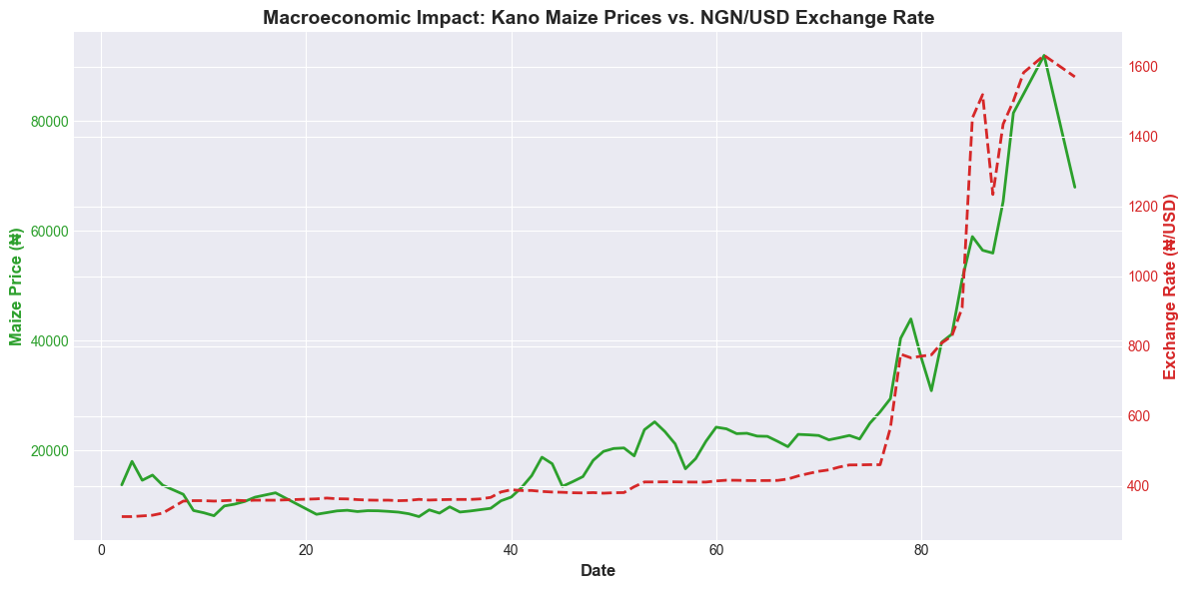
Figure 3.8: Dual-axis time-series showing the relationship between wholesale Maize prices and NGN/USD exchange rate movement.

To statistically validate these observations, a Pearson correlation analysis was performed on the merged dataset. The correlation matrix (Figure 3.9) showed that while NDMI maintained a relationship with crop conditions, the exchange rate had the strongest positive correlation with maize, sorghum, and millet prices.
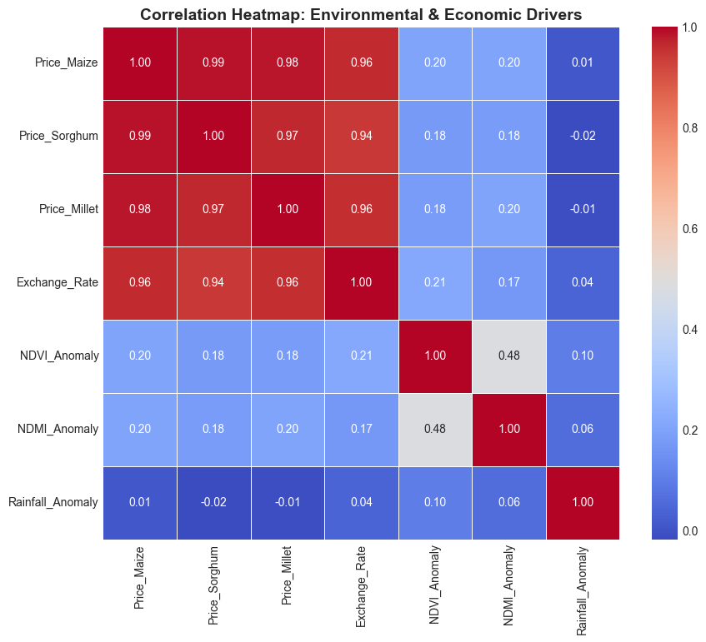
Figure 3.9: Correlation heatmap showing the relationships between environmental variables, the macroeconomic exchange rate, and target crop prices.

  - Tools and Techniques
The development and deployment of the Kano GeoAI framework are supported by a modern data science and software engineering technology stack. The system is designed to be modular, scalable, and efficient across all processing stages.
Core Development & Data Engineering
- Python 3.10+: The main programming language used for the entire system including data extraction scripts, the ETL pipeline, and machine learning workflows.
- Pandas & GeoPandas: Used for data manipulation, time-series processing, merging of datasets, and handling spatial data for the 44 Local Government Areas (LGAs).

Geospatial & Cloud Infrastructure
- Google Earth Engine (GEE): A cloud-based geospatial platform used to process large-scale Sentinel-2 and CHIRPS datasets. It performs satellite processing, crop masking, and extraction of aggregated environmental statistics.
- QGIS: Used for initial preprocessing of shapefiles and for generating static maps of the study area.
Database Architecture
- PostgreSQL, PostGIS & pgAdmin: The central data warehouse of the system. PostgreSQL stores structured data, while PostGIS handles spatial data such as LGA boundaries. pgAdmin is used for database management and monitoring.
- SQLAlchemy & GeoAlchemy2: Used to connect Python applications to the database and manage spatial data operations programmatically.
Machine Learning Engine
- XGBoost: The main predictive algorithm used for modeling complex relationships between environmental and economic variables.
- Scikit-Learn: Used for preprocessing, feature scaling, and model evaluation metrics.
Deployment & Visualization
- Streamlit: Used to deploy the machine learning models into an interactive web application, including the Scenario Simulator.
- Plotly: Used to create interactive charts and spatial visualizations such as LGA-level heatmaps and time-series plots.
  - Implementation Architecture and System Structure
To ensure scalability and proper software engineering practices, the system follows a modular and decoupled architecture. The project avoids a single monolithic structure and instead separates components based on functionality (Figure 3.10). The system is organized into the following layers:
- Data Engineering Layer: This layer contains scripts responsible for data extraction and processing, including fetch_satellite_api.py, fetch_prices_api.py, and etl_pipeline.py. It handles data ingestion from external APIs and loads processed data into the PostgreSQL/PostGIS database.
- Machine Learning Layer: This layer handles feature engineering and model training. build_features.py prepares input variables, while training scripts such as train_price_models.py and train_stress_model.py build the predictive models. The trained models are saved as serialized .pkl files.
- Deployment Layer: This layer contains the Streamlit application dashboard.py and the inference engine inference.py. It loads trained models and provides real-time predictions through an interactive dashboard.
- 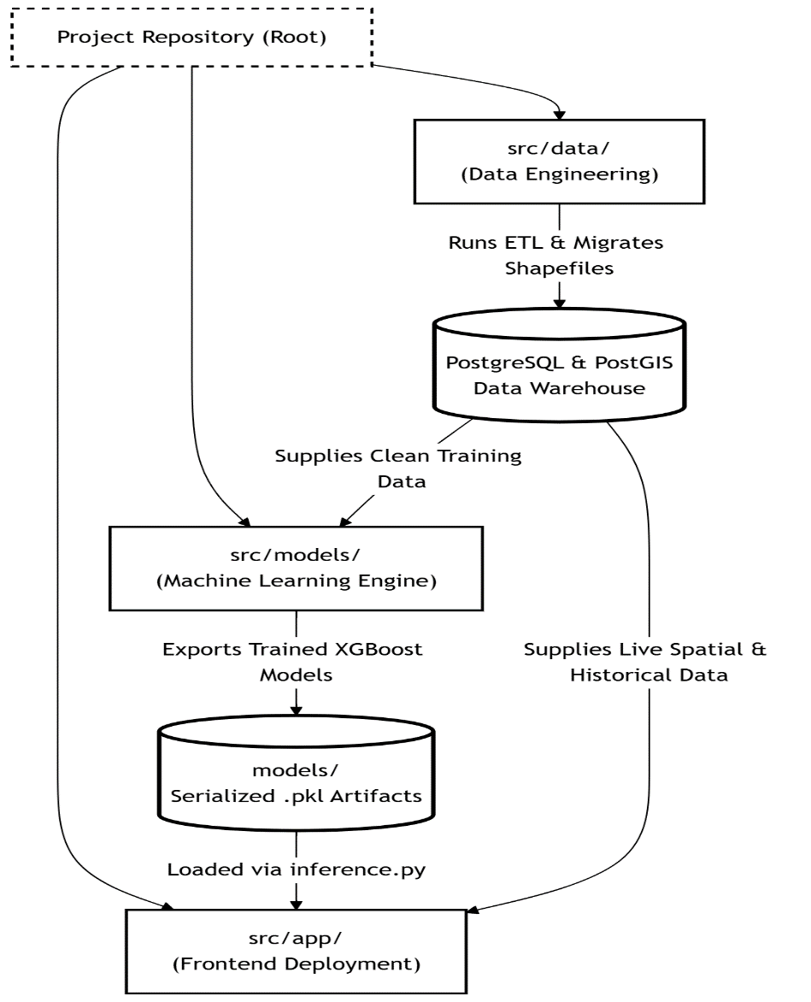
Figure 3.10: Implementation architecture showing the modular system design and data flow from data extraction scripts, through the PostgreSQL/PostGIS database, into model training and final Streamlit deployment.
CHAPTER FOUR
IMPLEMENTATION, RESULTS AND DISCUSSION
  - Introduction
This chapter presents the implementation, evaluation results, and discussion of the Kano GeoAI Food Security Framework. It explains the data engineering processes, evaluates the performance of the XGBoost machine learning models, and analyzes the effect of combining macroeconomic indicators with environmental satellite data. The chapter also describes the deployment of the interactive decision-support dashboard designed for real-world policy use.
  - Data Engineering and Pipeline Implementation
The implementation began with the development of an automated Extract, Transform, Load (ETL) pipeline designed to integrate remote sensing data with economic indicators. The pipeline retrieves grain price data from the FEWS NET API for the Dawanau International Market, as well as the Google Earth Engine (GEE) API for Sentinel-2 imagery and CHIRPS rainfall data across the 44 Local Government Areas (LGAs) of Kano State.
During data preprocessing, a key challenge was the presence of missing values and inconsistencies in the raw market data, including mixed retail and wholesale entries. To ensure consistency, only wholesale prices (per 100kg) were retained for analysis.
To handle missing timestamps, a continuous time index was created using a fixed monthly frequency. Missing values were then addressed using linear interpolation to maintain temporal continuity. This produced a complete 96-month time-series dataset covering 2017 to 2024, ensuring consistency for time-dependent feature engineering such as lag variables.
  - Environmental Baseline Analysis
Before applying the predictive models, a baseline analysis was conducted using the historical satellite data to understand the natural agricultural patterns in Kano State.
Time-series analysis of the aggregated Sentinel-2 and CHIRPS data shows clear and consistent seasonal cycles (Figure 4.1). Rainfall typically reaches its peak between July and August, followed by a peak in vegetation greenness (NDVI) around September. This pattern reflects the natural crop growth cycle, where rainfall supports vegetation development with a short time delay.
This observed lag relationship provides stron justification for the use of lagged environmental features (such as Rainfall_Lag1 and NDMI_Lag1) in the machine learning model.
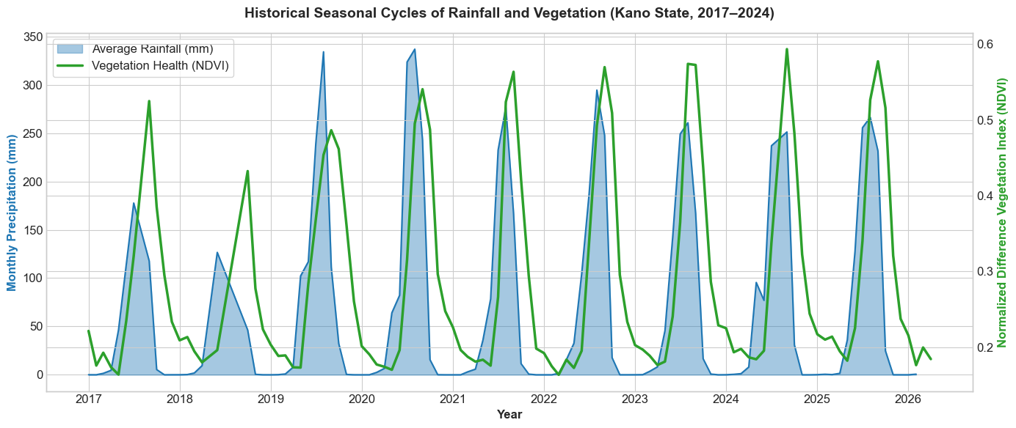
Figure 4.1: Dual-axis time-series showing seasonal patterns of Rainfall and Vegetation Health (NDVI) in Kano State (2017–2024), highlighting the lag between peak rainfall and peak vegetation growth.
Although the overall state pattern appears stable, further spatial analysis shows that vegetation conditions vary across different areas. A spatial distribution map of average NDVI values (Figure 4.2) indicates that some northern LGAs, such as Tsanyawa and Makoda, experience lower vegetation health compared to southern regions.
This suggests that agricultural stress is unevenly distributed, with certain areas being more vulnerable than others.
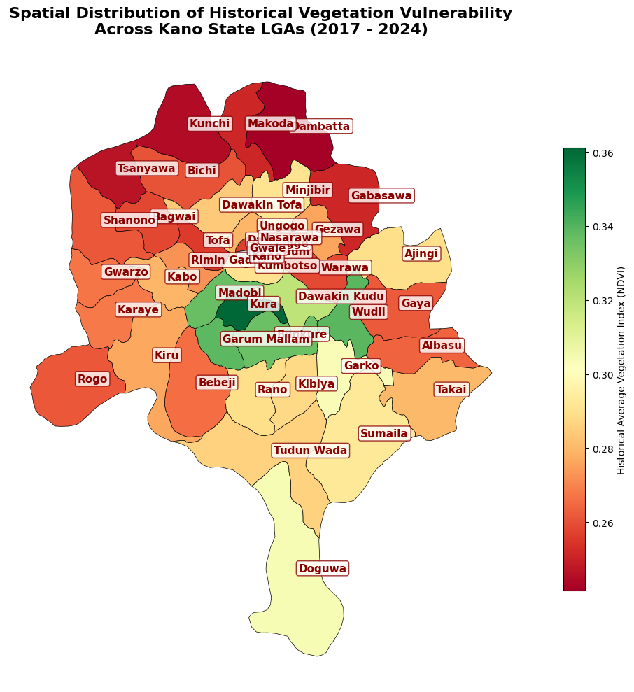
Figure 4.2: Choropleth heatmap showing the spatial distribution of average NDVI across Kano State LGAs, highlighting areas of low vegetation health as zones of higher agricultural stress.
  - Feature Importance and the Macroeconomic Shift
Initial experiments showed that using only environmental variables (NDVI, NDMI, and rainfall) produced weak predictions, especially for the 2023–2024 period. During this time, vegetation conditions were relatively healthy, yet grain prices increased sharply.
To explain this behavior, the NGN/USD exchange rate was added as a feature in the model. After retraining the XGBoost model with both environmental and economic variables, the feature importance results clearly showed a shift.
While environmental variables such as NDMI_Lag and historical price trends (Price_Lag1) remained important, the exchange rate (Exchange_Rate_Lag1) became one of the strongest predictors. This shows that currency devaluation plays a major role in driving food prices, even when environmental conditions are favorable.
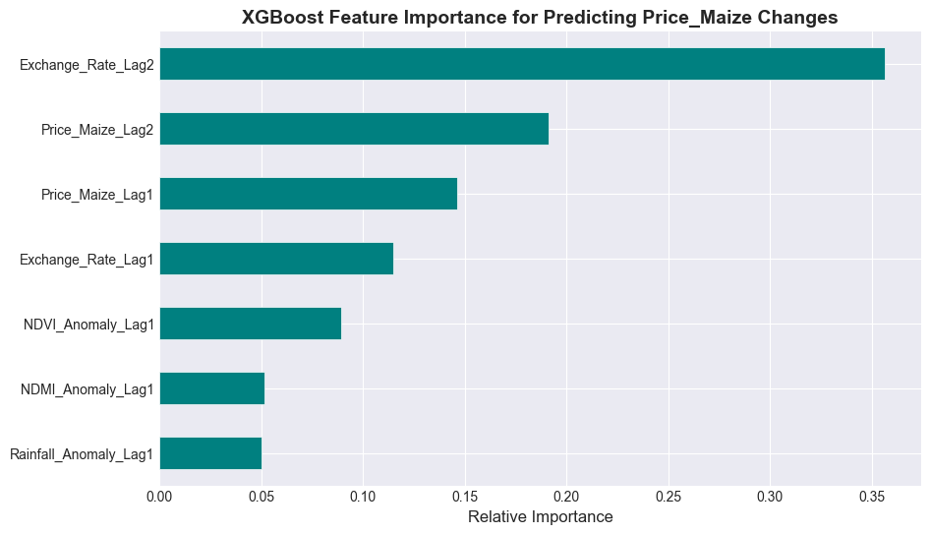
Figure 4.3: XGBoost Feature Importance chart showing the relative contribution of environmental and macroeconomic variables.
  - Model Evaluation and Comparative Analysis
To validate the effectiveness of the proposed GeoAI system, it was necessary to evaluate multiple forecasting algorithms. The models were tested against the final 12 months of the dataset (2024), a period characterized by extreme macroeconomic volatility of commodity prices. Performance was measured using Root Mean Square Error (RMSE), Mean Absolute Error (MAE), and Mean Absolute Percentage Error (MAPE).
    - Baseline Statistical Models (ARIMA & SARIMAX)
The experimentation began with traditional time-series forecasting. An Autoregressive Integrated Moving Average (ARIMA) model was trained using strictly historical price data. Because ARIMA assumes that future trends are linear extensions of the past, it entirely failed to predict the exponential price spikes of 2024.
Target Crop | Model Type | RMSE | MAE | MAPE
Maize | ARIMA (History Only) | 35,221 | ₦32,481 | 43.10%
 | SARIMAX (with Env Lags) | 30,767 | ₦28,706 | 38.44%
Sorghum | ARIMA (History Only) | 32,163 | ₦28,404 | 40.54%
 | SARIMAX (with Env Lags) | 31,484 | ₦27,620 | 39.30%
Millet | ARIMA (History Only) | 28,870 | ₦27,047 | 38.92%
 | SARIMAX (with Env Lags) | 24,156 | ₦22,780 | 32.98%
To improve upon this, a SARIMAX (Seasonal ARIMA with eXogenous factors) model was implemented by adding environmental variables (NDVI, NDMI, and Rainfall) into the statistical model. Although this slightly improve the results, the model still struggled to process the non-linear relationship between environmental stress and extreme currency devaluation, resulting in an average error margin (MAPE) hovering near 40%. The complete performance metrics for these baseline models are detailed in Table 4.1
Table 4.1: Performance of Baseline Statistical Models (ARIMA & SARIMAX)
    - Rigorous Validation (XGBoost Rolling-Origin Cross-Validation)
To overcome the limitations of linear models, the system transitioned to XGBoost, an advanced gradient-boosted decision tree algorithm capable of capturing complex, non-linear interactions. To ensure reliable evaluation and avoid overfitting, the model was evaluated using a rolling-origin (walk-forward) cross-validation strategy. Instead of a single static test split, the model was forced to retrain itself every month as new data arrived, simulating a real-world production environment.
When evaluated across the test period, the Rolling-Origin XGBoost model achieved an average RMSE of 11,173 and an average MAE of ₦9,800. More importantly, it reduce the average Mean Absolute Percentage Error (MAPE) to roughly 15%. This approach significantly reduces the forecasting error, proving that dynamically retraining tree-based algorithms is vastly superior for modeling non-stationary Nigerian agricultural markets compared to traditional methods.
    - The Winning Model (Advanced Differencing XGBoost)
Although the standard XGBoost model performed well, it still faced challenges in handling non-stationary nature of price trends during periods of rapid inflation. To improve performance, a differencing strategy was applied.
Instead of predicting the absolute price of grains, the target variable was transformed to represent the month-to-month change in price. This allows the model to focus on short-term variations rather than long-term inflation trends.
Target Crop | Model Type | RMSE | MAE | MAPE
Maize | XGBoost (Standard Baseline) | 41,379 | ₦38,463 | 51.28%
 | XGBoost (Walk-Forward CV) | 10,324 | ₦9,055 | 13.28%
 | XGBoost (Advanced Differencing) | 10,037 | ₦8,292 | 11.88%
Sorghum | XGBoost (Standard Baseline) | 28,968 | ₦24,349 | 33.95%
 | XGBoost (Walk-Forward CV) | 11,599 | ₦10,348 | 16.64%
 | XGBoost (Advanced Differencing) | 8,743 | ₦7,955 | 12.26%
Millet | XGBoost (Standard Baseline) | 33,968 | ₦32,034 | 46.25%
 | XGBoost (Walk-Forward CV) | 11,596 | ₦9,998 | 15.49%
 | XGBoost (Advanced Differencing) | 12,170 | ₦10,604 | 15.67%
This adjustment led to the best performance among all tested models and was therefore selected as the final model for deployment. During 2024, when grain prices exceeded ₦80,000 per 100kg, the model achieved an average Mean Absolute Percentage Error (MAPE) of 13.27% across all crops. This level of accuracy indicates that the model is reliable for capturing price movements under both stable and volatile market conditions.
Table 4.2 Comparative Performance of XGBoost models Across Crops (Standard, Rolling Validation, and Advanced Differencing)
    - Visualizing Model Performance
To illustrate the advantage of the non-linear machine learning approach, the forecasting outputs of all models were visualized and compared against the actual observed market prices.
As shown in Figure 4.4, the baseline statistical models (ARIMA and SARIMAX) produced relatively flat and linear forecasts, failing to capture the sharp and rapid price increases observed during the test period. These models were unable to adapt to sudden market shocks, particularly those driven by macroeconomic instability.
In contrast, the XGBoost model with the Advanced Differencing strategy closely tracked the actual price movements. It was able to capture both the direction and magnitude of market fluctuations, including sudden spikes, demonstrating a much stronger ability to model real-world volatility.
This improvement is further supported by the quantitative evaluation presented in Figure 4.5, where the Mean Absolute Error (MAE) of each model is compared. The results show a significant reduction in forecasting error when transitioning from traditional statistical models to the gradient-boosted tree approach.
Overall, these visual and numerical results confirm that the proposed XGBoost-based framework provides a more accurate and reliable method for forecasting grain prices in a highly volatile economic environment.
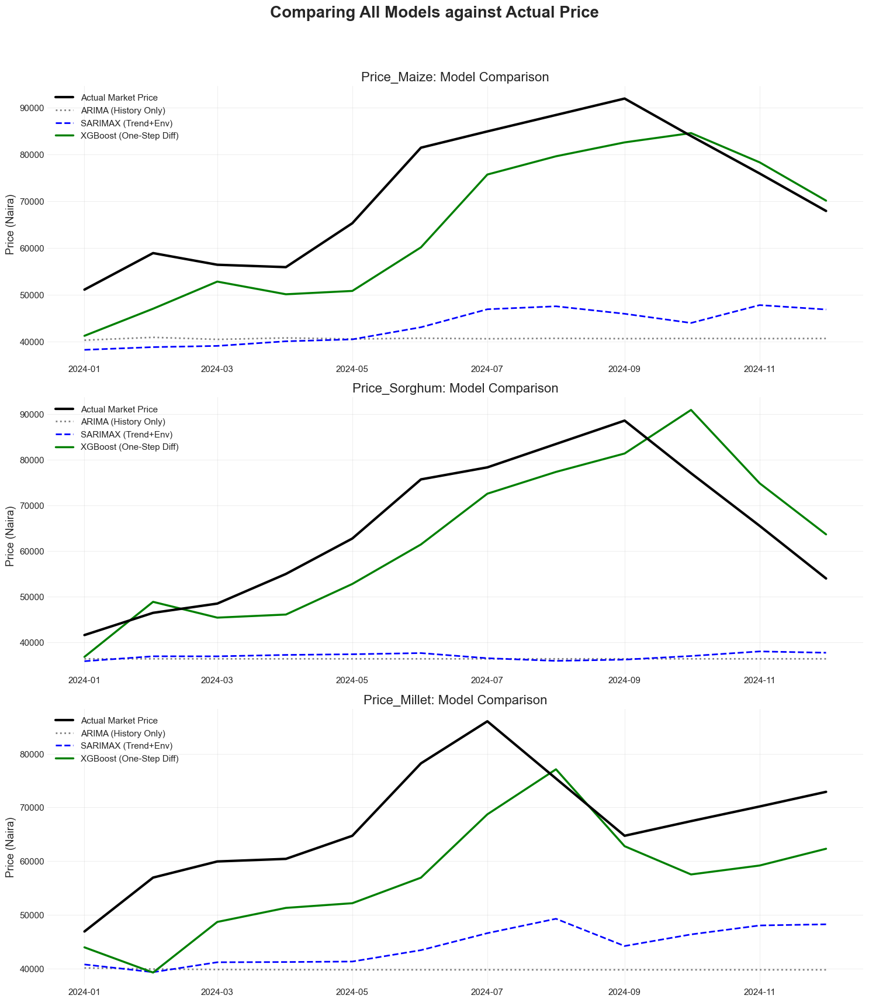
Figure 4.4: Time-series comparison of forecasting models across staple crops (2024). The graph highlights the limitations of linear models (ARIMA/SARIMAX) in capturing market spikes, compared to the improved performance of the XGBoost Advanced Differencing model.

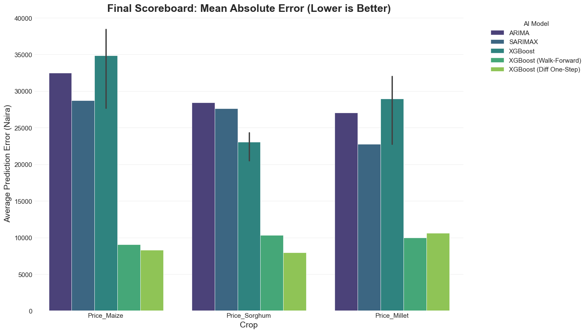

Figure 4.5: Comparative error analysis of all crop forecasting models. The grouped bar chart presents the Mean Absolute Error (MAE) across models, demonstrating the significant performance improvement achieved by the XGBoost-based approach.

  - Environmental Forecasting: Vegetation Stress (NDVI)

Beyond economic forecasting, a key component of the GeoAI framework is the ability to provide early warnings on agricultural conditions. To achieve this, a dedicated XGBoost model was trained to forecast future vegetation health (NDVI Anomaly) across Kano State based on historical rainfall distribution and canopy moisture (NDMI lags).

When evaluated on unseen data, the vegetation stress model achieved a Root Mean Square Error (RMSE) of 0.5934. Since the target variable is expressed as a Z-score (Standard Anomaly Index centered at zero), this result indicates that the model can predict vegetation conditions within approximately half a standard deviation of the observed values. This level of accuracy is sufficient for detecting early signs of agricultural stress and supporting timely intervention.

To assess the model’s predictive capability, a one-month-ahead forecast was compared with actual satellite-derived NDVI anomalies (Figure 4.6). The results show that the model effectively captures the seasonal decline in vegetation health and is able to anticipate critical stress conditions. In particular, the model successfully predicts when vegetation indices approach or fall below the −1.0 threshold, which is commonly associated with drought conditions.

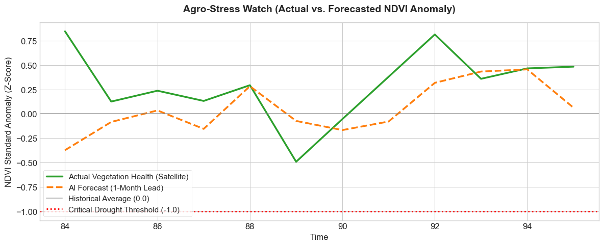

Figure 4.6: Time-series comparison of predicted and observed NDVI anomalies. The one-month-ahead forecast demonstrates the model’s ability to track vegetation decline and identify drought thresholds.

To further interpret the model’s behavior, a Feature Importance analysis was conducted (Figure 4.7). The results indicate that short-term canopy moisture conditions (NDMI_Lag1) and cumulative rainfall anomalies are the most influential predictors of future vegetation health. This aligns with the underlying environmental theory that moisture availability is a primary driver of crop condition in semi-arid regions.

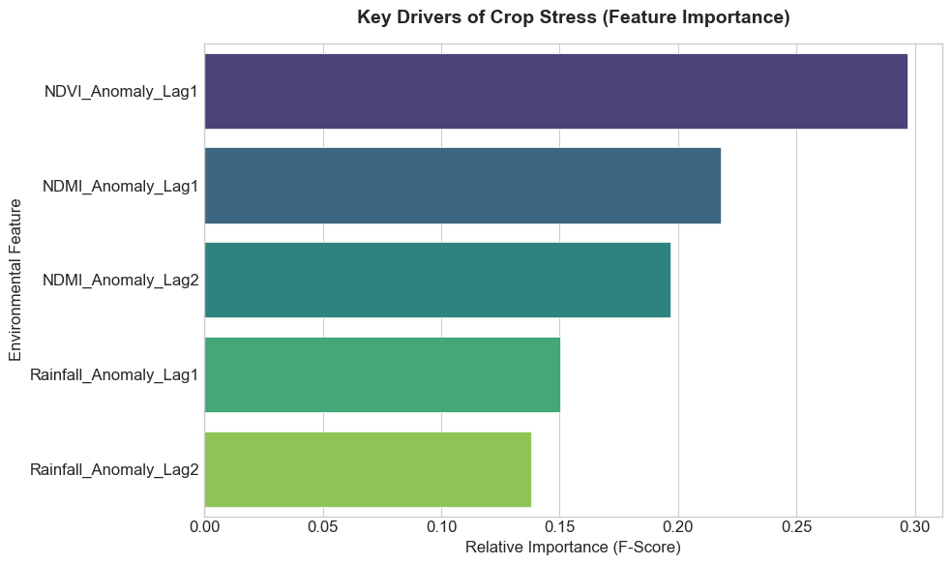
Figure 4.7: Feature Importance matrix for the vegetation stress model, highlighting the dominant role of lagged NDMI and rainfall anomalies in predicting future NDVI conditions.
  - System Deployment: The GeoAI Decision Support Dashboard
To convert the machine learning outputs into practical decision-making tools, the system was deployed as a Streamlit web application. The application is connected to the PostGIS-enabled PostgreSQL database, allowing it to retrieve both spatial geometries and processed data in real time. By rendering spatial data through a Plotly Mapbox interface, enables fast visualization without relying on external files or API calls during runtime. The dashboard provides two main functions:
- Live Spatial Heatmap: A choropleth map displays NDVI anomalies and rainfall distribution across all 44 LGAs in Kano State. It supports quick identification of high-risk areas, especially northern LGAs such as Tsanyawa and Makoda, which consistently show higher vegetation stress.
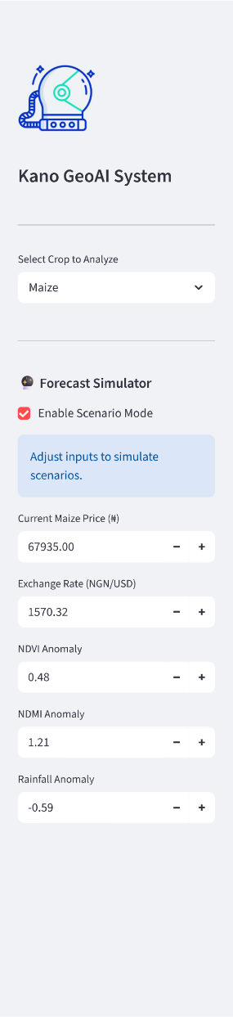
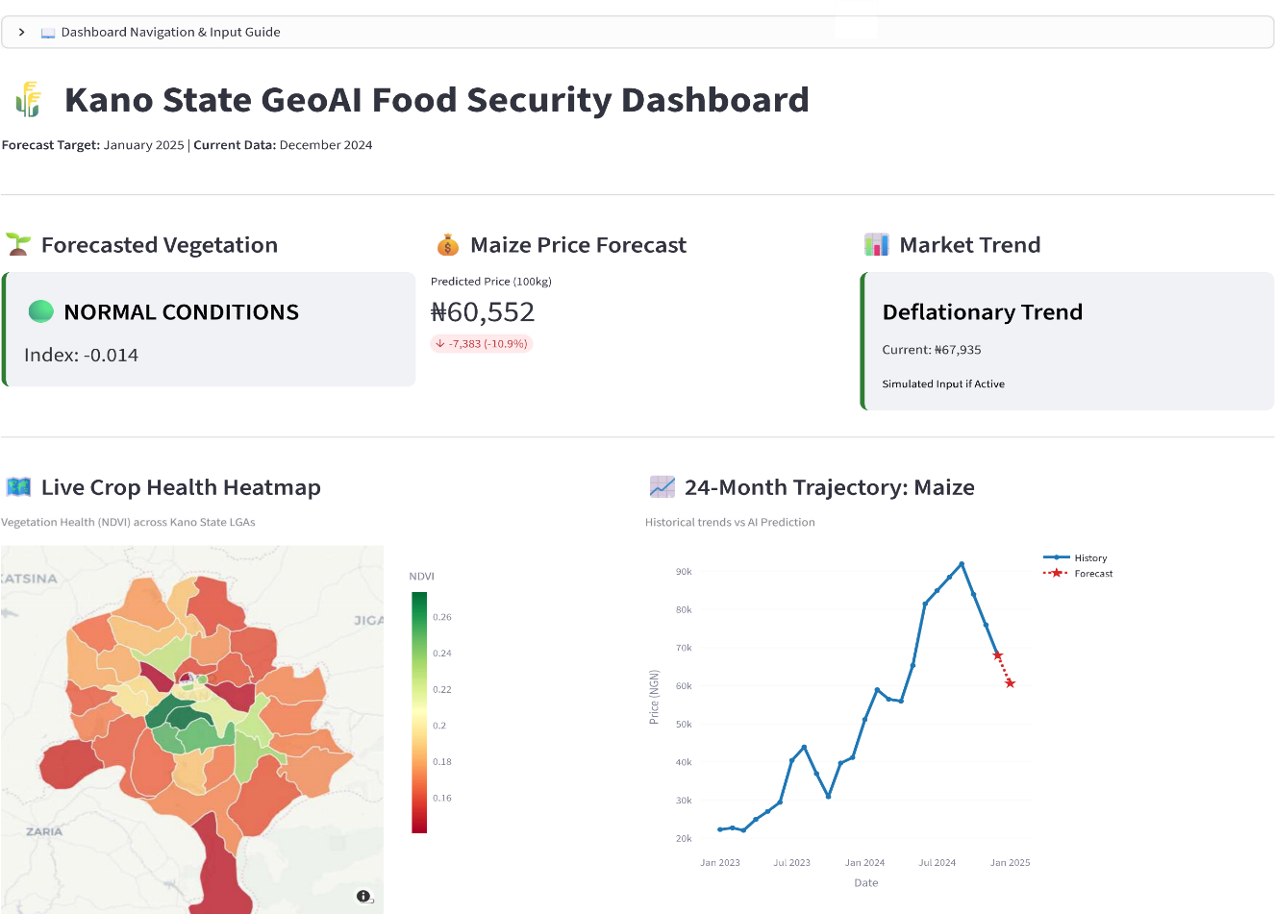
- Scenario Simulator: This feature allows users to adjust key inputs (e.g., exchange rate or rainfall anomalies) and immediately observe changes in predicted grain prices. It turns the system into an interactive decision-support tool rather than a static monitoring dashboard.

Figure 4.8: User interface of the Kano GeoAI Decision Support Dashboard. The interface integrates a spatial heatmap and an interactive Scenario Simulator, providing real-time visualization and predictive analysis.
Note: The deployed interface demonstrates the successful operationalization of the Advanced Differencing XGBoost model. By adjusting macroeconomic and environmental parameters through the dashboard controls, users can instantly visualize how changes in climate conditions or currency fluctuations influence future grain prices. This eliminates the need for technical expertise, making the system accessible and practical for policymakers and stakeholders.
  - Discussion of Findings
The findings of this study strongly support the core hypothesis that modern agricultural intelligence systems cannot depend solely on environmental data. While traditional early-warning approaches based on vegetation indices such as NDVI are effective in detecting physical drought conditions, they are insufficient for predicting food insecurity when the primary drivers are economic rather than climatic.
By integrating remote sensing indicators (NDVI, NDMI, and CHIRPS rainfall data) with macroeconomic variables, particularly the NGN/USD exchange rate, this study develops a unified predictive framework. The combination of these data sources within an automated PostgreSQL database and XGBoost machine learning pipeline enables the system to capture both environmental stress and economic pressures simultaneously.
The low Mean Absolute Error (MAE) achieved by the model demonstrates its ability to effectively learn the complex, non-linear relationships that exist between currency depreciation, rising production and transportation costs, and the resulting increase in grain prices at the Dawanau International Market. This highlights the importance of incorporating macroeconomic dynamics into agricultural forecasting models.
Overall, the Kano GeoAI Framework illustrates that transitioning from static, reactive reporting methods to proactive, machine learning-driven simulation significantly improves the ability to anticipate and respond to food security challenges. This integrated approach provides a more reliable and practical tool for supporting policy decisions and enhancing agricultural resilience in Northern Nigeria.

CHAPTER FIVE
SUMMARY, CONCLUSION, AND RECOMMENDATIONS
  - Summary of the Study
This research developed and implemented the Kano GeoAI Food Security Framework, an automated, end-to-end Geospatial Artificial Intelligence system designed to predict crop stress and staple food prices. The study addressed key limitations in traditional agricultural monitoring by integrating high-resolution environmental satellite data (NDVI, NDMI, and CHIRPS Rainfall) with macroeconomic indicators, particularly the NGN/USD exchange rate.
An automated Extract, Transform, and Load (ETL) pipeline was designed to collect, process and merge data from the Google Earth Engine and FEWS NET APIs into a centralized PostgreSQL data warehouse, utilizing the PostGIS extension for spatial data management. To address the non-lnear and inflation-driven nature of the Nigerian economy, an Advanced Differencing XGBoost machine learning model was implemented for price forecasting.
The economic forecasting model achieved strong performance, with an average Mean Absolute Percentage Error (MAPE) of 13.27% across major staple grains (Maize, Sorghum, and Millet), and a Mean Absolute Error (MAE) of ₦8,083 for wholesale maize during the high-volatility of 2024. At the same time, the environmental forecasting component recorded a Root Mean Square Error (RMSE) of 0.5934 in predicting vegetation stress.
The system outputs were deployed through an interactive Streamlit dashboard, providing a spatial heatmap for monitoring environmental conditions and a scenario simulator for evaluating economic and climate impacts on future prices. Overall, the study demonstrates that integrating macroeconomic indicators with remote sensing data within a machine learning framework offers a more effective and proactive approach to food security monitoring in developing economies.
  - Conclusion
The primary conclusion of this study is that agricultural intelligence systems in developing economies cannot rely solely on environmental data. While remote sensing indicators such as vegetation and moisture indices are effective for detecting physical crop stress—evidenced by the NDVI forecasting RMSE of 0.5934—they are insufficient for explaining the extreme price fluctuations observed in Kano State during 2023 and 2024.
The inclusion of the NGN/USD exchange rate within the predictive framework demonstrates that rapid currency depreciation has become a dominant driver of food price inflation, in many cases outweighing the influence of local agricultural conditions. Traditional statistical models such as ARIMA and SARIMAX were unable to adapt to these non-stationary dynamics, resulting in poor forecasting performance.
In contrast, the XGBoost model, combined with an Advanced Differencing strategy, effectively captured the complex and non-linear interactions between environmental conditions, macroeconomic factors, and commodity prices. This approach achieved a reliable average Mean Absolute Percentage Error (MAPE) of 13.27%, indicating strong predictive capability even under highly volatile conditions.
Overall, the Kano GeoAI Framework demonstrates a shift from reactive analysis to proactive, data-driven forecasting. It provides a scalable and practical model for anticipating food security challenges and supporting informed decision-making across Northern Nigeria.
  - Limitations of the Study
While the Kano GeoAI Food Security Framework achieved its objectives and demonstrated strong predictive performance, several limitations should be acknowledged:
- Temporal Resolution Constraints: The system operates on a monthly time scale, mainly due to the availability of FEWS NET market data and the need to aggregate daily satellite observations into stable monthly values. As a result, the model is suitable for medium-term forecasting but cannot capture short-term market fluctuations that occur within weeks or days.
- Spatial Aggregation and Mixed Cropping: Although the Google Earth Engine pipeline applies the Dynamic World dataset to isolate agricultural land, farming practices in Kano State often involve intercropping. Since vegetation indices (NDVI and NDMI) are aggregated at the LGA level, the system cannot distinguish between different crop types within the same area. This reduces crop-specific precision.
- Exclusion of Socio-Political Factors: The model incorporates macroeconomic data such as the NGN/USD exchange rate but does not explicitly include localized socio-political variables, such as insecurity or supply chain disruptions. While their effects may be indirectly reflected in price changes, the model cannot isolate or quantify these factors independently.
- Dependence of External Cloud Services: The system relies heavily on external platforms, particularly the Google Earth Engine API. Any changes in service availability, API structure, or access policies could affect the stability and long-term sustainability of the framework.
  - Recommendations for Future Work
Although the Kano GeoAI Framework achieved its core objectives, several improvements can be made to enhance its scalability, accuracy, and real-world applicability:
    - Real-Time Data Integration and MLOps Automation: The current system generates predictions dynamically, but future work should introduce a full Machine Learning Operations (MLOps) layer. Tools such as Prefect or Apache Airflow can be used to automate data pipelines, while MLflow can support experiment tracking and model versioning. This would allow the system to retrain itself automatically as new satellite and economic data become available, improving reliability over time.
    - Geographical and Commodity Expansion: The framework can be extended beyond Kano State to cover other states in the Northwest region, such as Kaduna, Katsina, and Jigawa. Expanding the system to include additional staple crops like rice and cowpeas would also improve its relevance, since these commodities are similarly affected by environmental and economic conditions.
    - Incorporation of Socio-Political Indicators: To address the current limitation of excluding local disruptions, future versions of the system can integrate socio-political data using Natural Language Processing (NLP). For example, data from news platforms or social media can be analyzed to generate a “conflict or insecurity index.” This would allow the model to better capture the impact of factors such as rural insecurity or supply chain disruptions on food prices, separate from general economic inflation.

REFERENCES
Brown, C. F., Brumby, S. P., Guzder-Williams, B., Birch, T., Hyde, S. B., Mazzariello, J., ... & Tait, A. M. (2022). Dynamic World, Near real-time global 10 m land use land cover mapping. Scientific Data, 9(1), 251.
Chen, T., & Guestrin, C. (2016). XGBoost: A scalable tree boosting system. In Proceedings of the 22nd ACM SIGKDD International Conference on Knowledge Discovery and Data Mining (pp. 785-794). Association for Computing Machinery.
Das, A. C., Shahriar, S. A., Chowdhury, M. A., Hossain, M. L., Mahmud, S., Tusar, M. K., Ahmed, R., & Salam, M. A. (2023). Assessment of remote sensing-based indices for drought monitoring in the north western region of Bangladesh. Heliyon, 9(7), e13016.
Famine Early Warning Systems Network (FEWS NET). (2024). Nigeria historical and current retail market prices. United States Agency for International Development (USAID). Retrieved from https://fews.net
Funk, C., Peterson, P., Landsfeld, M., Pedreros, D., Verdin, J., Shukla, S., ... & Michaelsen, J. (2015). The climate hazards infrared precipitation with stations—A new environmental record for monitoring extremes. Scientific Data, 2(1), 1-21.
Gaznayee, H. A. A., Zaki, S. H., Al Quraishi, A. M. F., Aliehsan, P. H., Hakzi, K. K., Razvanchy, H. A. S., Riksen, M., & Mahdi, K. (2023). Integrating remote sensing techniques and meteorological data to assess the ideal irrigation system performance scenarios for improving crop productivity. Water, 15(8), 1605.
Gorelick, N., Hancher, M., Dixon, M., Ilyushchenko, S., Thau, D., & Moore, R. (2017). Google Earth Engine: Planetary-scale geospatial analysis for everyone. Remote Sensing of Environment, 202, 18-27.
Huang, S., Tang, L., Hupy, J. P., Wang, Y., & Shao, G. (2021). A commentary review on the use of normalized difference vegetation index (NDVI) in the era of popular remote sensing. Journal of Forestry Research, 32, 1–6.
Obe, R. O., & Hsu, L. S. (2021). PostGIS in action (3rd ed.). Manning Publications.
Otitoju, M. A., Fidelis, E. S., Salihu, M. U., & Clement, C. (2024). A review of the Nigerian floating exchange rate regime and its effect on food prices. International Journal of Research and Innovation in Social Science (IJRISS), 8(11), 3455–3465.
Pedregosa, F., Varoquaux, G., Gramfort, A., Michel, V., Thirion, B., Grisel, O., ... & Duchesnay, E. (2011). Scikit-learn: Machine learning in Python. Journal of Machine Learning Research, 12, 2825-2830.
QGIS Development Team. (2024). QGIS geographic information system. Open Source Geospatial Foundation Project. Retrieved from https://qgis.org
Regis, M. D. S., Ly, M., Kouakou, K., Bichet, A., Diedhiou, A., Coulibaly, H. S. J., Kouakou, C. A. K., Coulibaly, J. H. T., Obahoundje, S., & Savané, I. (2020). Using the CHIRPS dataset to investigate historical changes in precipitation extremes in West Africa. Climate, 8(7), 84.
Sanusi, O. I., Safi, K., & Adeeko, O. (2022). Forecasting agricultural commodity price using different models: A case study of widely consumed grains in Nigeria. Agricultural and Resource Economics: International Scientific E-Journal, 8(2), 124–140.
Streamlit Inc. (2024). Streamlit: The fastest way to build and share data apps. Retrieved from https://streamlit.io
Varouchakis, E. A., Bacopoulos, T., Gaki-Papanastassiou, K., & Panagopoulos, G. (2025). Spatiotemporal analysis of vegetation health and moisture dynamics in rehabilitated mining quarries using satellite imagery. Environmental Processes.

APPENDICES
APPENDIX A: SOURCE CODE REPOSITORY
To ensure brevity while preserving the technical depth of the study, the complete codebase of the Kano GeoAI Framework is hosted on GitHub. The repository contains all system components, including data engineering pipelines, API integration scripts, machine learning models, and evaluation modules. The full implementation can be accessed at: [https://github.com/ahmad-ig/kano-geoai]
The key architectural scripts that power the system are summarized in the appendices below.
APPENDIX B: GOOGLE EARTH ENGINE (GEE) DATA EXTRACTION
This module handles the automated extraction of environmental data using the Google Earth Engine Python API. It generates a Stable Crop Mask based on the Dynamic World dataset, extracts Sentinel-2 vegetation indices (NDVI, NDMI) and CHIRPS rainfall data, performs monthly spatial aggregation across all Kano State LGAs, and loads the results into the PostgreSQL staging tables.
import sys
import os
import ee
import pandas as pd
from datetime import datetime
from calendar import monthrange
from config import settings

def fetch_satellite_data():
ee.Initialize(project=settings.GEE_PROJECT_ID)

# Define Region of Interest (Kano State LGAs)
gaul = ee.FeatureCollection("projects/geoai-final-year-project/assets/gadm41_NGA_2")
kano_lgas = gaul.filter(ee.Filter.eq('NAME_1', 'Kano'))

start_date = '2017-01-01'
end_date = datetime.now().strftime('%Y-%m-%d')

# Calculate Stable Crop Mask (Dynamic World)
dw = ee.ImageCollection("GOOGLE/DYNAMICWORLD/V1").filterDate('2017-01-01', '2026-12-31').filterBounds(kano_lgas)
crop_mask = dw.select('label').mode().eq(4).clip(kano_lgas)

def mask_s2_clouds_and_filter(image):
scl = image.select('SCL')
mask = scl.eq(4).Or(scl.eq(5))
return image.updateMask(mask)

def add_indices(image):
ndvi = image.normalizedDifference(['B8', 'B4']).rename('NDVI')
ndmi = image.normalizedDifference(['B8', 'B11']).rename('NDMI')
return image.addBands([ndvi, ndmi])

s2 = (ee.ImageCollection('COPERNICUS/S2_SR_HARMONIZED')
.filterDate(start_date, end_date)
.filterBounds(kano_lgas)
.filter(ee.Filter.lt('CLOUDY_PIXEL_PERCENTAGE', 30))
.map(mask_s2_clouds_and_filter)
.map(add_indices)
.select(['NDVI', 'NDMI']))

chirps = ee.ImageCollection("UCSB-CHG/CHIRPS/DAILY").filterDate(start_date, end_date).select('precipitation')

all_data = []
dates = pd.date_range(start=start_date, end=end_date, freq='MS')

for date in dates:
y, m = date.year, date.month
month_start = f"{y}-{m:02d}-01"
_, last_day = monthrange(y, m)
month_end = f"{y}-{m:02d}-{last_day}"

s2_month = s2.filterDate(month_start, month_end).median().updateMask(crop_mask)
rain_month = chirps.filterDate(month_start, month_end).sum().rename('Rainfall')
combined = s2_month.addBands(rain_month)

try:
stats = combined.reduceRegions(collection=kano_lgas, reducer=ee.Reducer.mean(), scale=500, tileScale=4)
feature_list = stats.select(['NAME_2', 'NDVI', 'NDMI', 'Rainfall'], retainGeometry=False).getInfo()['features']

for feat in feature_list:
props = feat['properties']
all_data.append({
'period_start': date,
'LGA_NAME': props.get('NAME_2'),
'NDVI': props.get('NDVI'),
'NDMI': props.get('NDMI'),
'Rainfall': props.get('Rainfall')
})
except Exception as e:
pass

df = pd.DataFrame(all_data)
df.to_sql(name='raw_env_data', con=settings.DB_ENGINE, if_exists='replace', index=False)

if __name__ == "__main__":
fetch_satellite_data()

APPENDIX C: EXTRACT, TRANSFORM, LOAD (ETL) PIPELINE
The etl_pipeline.py script serves as the central data processing engine. It performs data cleaning, fills missing market values using interpolation, computes Z-score anomalies for environmental variables, and generates temporal lag features required for machine learning models.
import numpy as np
import pandas as pd
from config import settings

def process_environmental_data():
query = "SELECT * FROM raw_env_data"
env_df = pd.read_sql(query, con=settings.DB_ENGINE)
env_df['period_start'] = pd.to_datetime(env_df['period_start'])
env_df['Month_Year'] = env_df['period_start'].dt.to_period('M')

monthly_env = env_df.groupby(['LGA_NAME', 'Month_Year']).agg({'NDVI': 'mean', 'NDMI': 'mean', 'Rainfall': 'sum'}).reset_index()
monthly_env['Date'] = monthly_env['Month_Year'].dt.to_timestamp()
monthly_env['Month_Num'] = monthly_env['Date'].dt.month

stats = monthly_env.groupby(['LGA_NAME', 'Month_Num'])[['NDVI', 'NDMI', 'Rainfall']].agg(['mean', 'std']).reset_index()
stats.columns = ['LGA_NAME', 'Month_Num', 'NDVI_Mean', 'NDVI_Std', 'NDMI_Mean', 'NDMI_Std', 'Rain_Mean', 'Rain_Std']

merged_env = pd.merge(monthly_env, stats, on=['LGA_NAME', 'Month_Num'], how='left')
merged_env['NDVI_Anomaly'] = ((merged_env['NDVI'] - merged_env['NDVI_Mean']) / merged_env['NDVI_Std'].replace(0, np.nan)).fillna(0)
merged_env['NDMI_Anomaly'] = ((merged_env['NDMI'] - merged_env['NDMI_Mean']) / merged_env['NDMI_Std'].replace(0, np.nan)).fillna(0)
merged_env['Rainfall_Anomaly'] = ((merged_env['Rainfall'] - merged_env['Rain_Mean']) / merged_env['Rain_Std'].replace(0, np.nan)).fillna(0)

return merged_env.groupby('Date')[['NDVI_Anomaly', 'NDMI_Anomaly', 'Rainfall_Anomaly']].mean().reset_index()

def merge_and_engineer_features(state_env, price_wide):
full_df = pd.merge(price_wide, state_env, on='Date', how='inner').set_index('Date').sort_index()
full_df = full_df.asfreq('MS')

numeric_cols = full_df.select_dtypes(include=['number']).columns
full_df[numeric_cols] = full_df[numeric_cols].interpolate(method='linear', limit_direction='both')
full_df = full_df.reset_index()

lag_features = settings.CROPS + ['NDVI_Anomaly', 'NDMI_Anomaly', 'Rainfall_Anomaly', 'Exchange_Rate']
for col in lag_features:
if col in full_df.columns:
full_df[f'{col}_Lag1'] = full_df[col].shift(1)
full_df[f'{col}_Lag2'] = full_df[col].shift(2)

return full_df.dropna()
APPENDIX D: XGBOOST PREDICTIVE ENGINE
The train_price_models.py module contains the core machine learning logic. It prepares lagged input features for each commodity and trains XGBoost regression models using a differencing approach. This method improves stability by predicting month-to-month price changes instead of absolute values.
import joblib
import xgboost as xgb
from config import settings

def get_price_features(crop, season_cols, available_columns):
features = [
f'{crop}_Lag1', f'{crop}_Lag2',
'NDVI_Anomaly_Lag1', 'NDVI_Anomaly_Lag2',
'NDMI_Anomaly_Lag1', 'NDMI_Anomaly_Lag2',
'Rainfall_Anomaly_Lag1', 'Rainfall_Anomaly_Lag2',
'Trend_Index'
]
if 'Exchange_Rate_Lag1' in available_columns:
features.extend(['Exchange_Rate_Lag1', 'Exchange_Rate_Lag2'])
return features + season_cols

def train_price_models(df):
season_cols = [c for c in df.columns if c.startswith('Seas_')]
settings.MODELS_DIR.mkdir(parents=True, exist_ok=True)

for crop in settings.CROPS:
features = get_price_features(crop, season_cols, df.columns)
target = f'{crop}_Diff'

if target not in df.columns:
continue

X = df[features]
y = df[target]

final_model = xgb.XGBRegressor(**settings.XGB_PARAMS)
final_model.fit(X, y)

save_path = settings.MODELS_DIR / f"model_{crop}.pkl"
joblib.dump(final_model, save_path)

if __name__ == "__main__":
from src.features.build_features import load_and_prep_data
df = load_and_prep_data()
train_price_models(df)

APPENDIX E: GEOAI DECISION SUPPORT DASHBOARD
The dashboard.py module implements the user interface using Streamlit. It integrates GeoPandas and Plotly Mapbox to visualize spatial vegetation stress across LGAs and provides an interactive Scenario Simulator for testing the impact of environmental and economic changes on future grain prices.
import streamlit as st
import pandas as pd
import geopandas as gpd
import plotly.express as px
import json
import src.app.inference as inference
from config import settings

st.set_page_config(page_title="Kano Food Security AI", layout="wide")
@st.cache_data(ttl=3600)
def get_predictions(manual_overrides=None):
last_row, last_date, all_cols = inference.load_latest_context()
if manual_overrides:
for col, val in manual_overrides.items():
last_row[col] = val
input_df, season_cols = inference.prepare_next_month_features(last_row, last_date, all_cols)
stress_val = inference.predict_stress(input_df)
price_preds = inference.predict_prices(input_df, last_row, season_cols)
next_date = last_date + pd.DateOffset(months=1)
return last_row, last_date, next_date, stress_val, price_preds

st.sidebar.title("🔮 Forecast Simulator")
enable_sim = st.sidebar.checkbox("Enable Scenario Mode")
manual_overrides = {}

if enable_sim:
manual_overrides['Exchange_Rate'] = st.sidebar.number_input("Exchange Rate (NGN/USD)", value=1500.0, step=50.0)
manual_overrides['Rainfall_Anomaly'] = st.sidebar.number_input("Rainfall Anomaly", value=0.0, step=0.1)

last_row, last_date, next_date, stress_val, price_preds = get_predictions(manual_overrides)

if price_preds:
st.title("🌾 Kano State Food Security Forecast")

col1, col2 = st.columns(2)
with col1:
st.subheader("🌱 Forecasted Vegetation")
st.metric("Stress Index", f"{stress_val:.3f}")
with col2:
pred_data = price_preds['Price_Maize']
st.subheader("💰 Maize Price Forecast")
st.metric("Predicted Price", f"₦{pred_data['pred']:,.0f}", f"{pred_data['change']:+,.0f}")

